Angular versioning

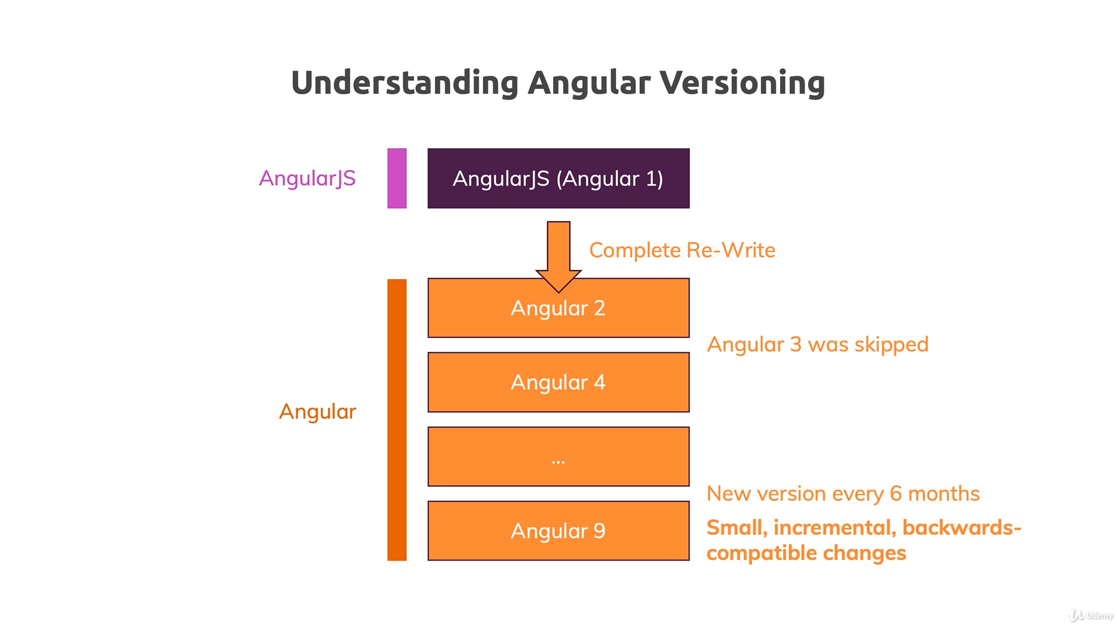

* Node js is used for bundeling and npm is used for Dependency management
* Npm install -g @angular/cli@latest is used to install the latest version of Angular

Angular contents

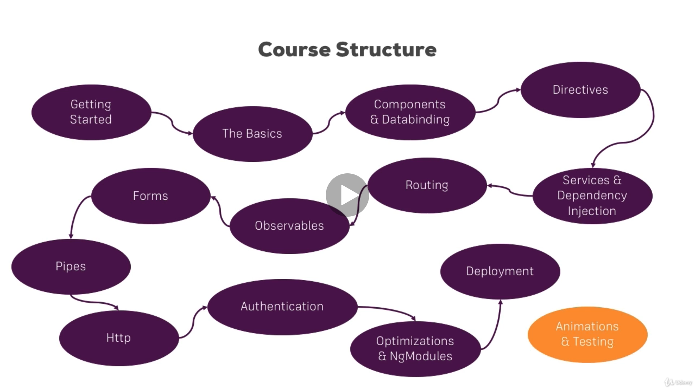

Type script

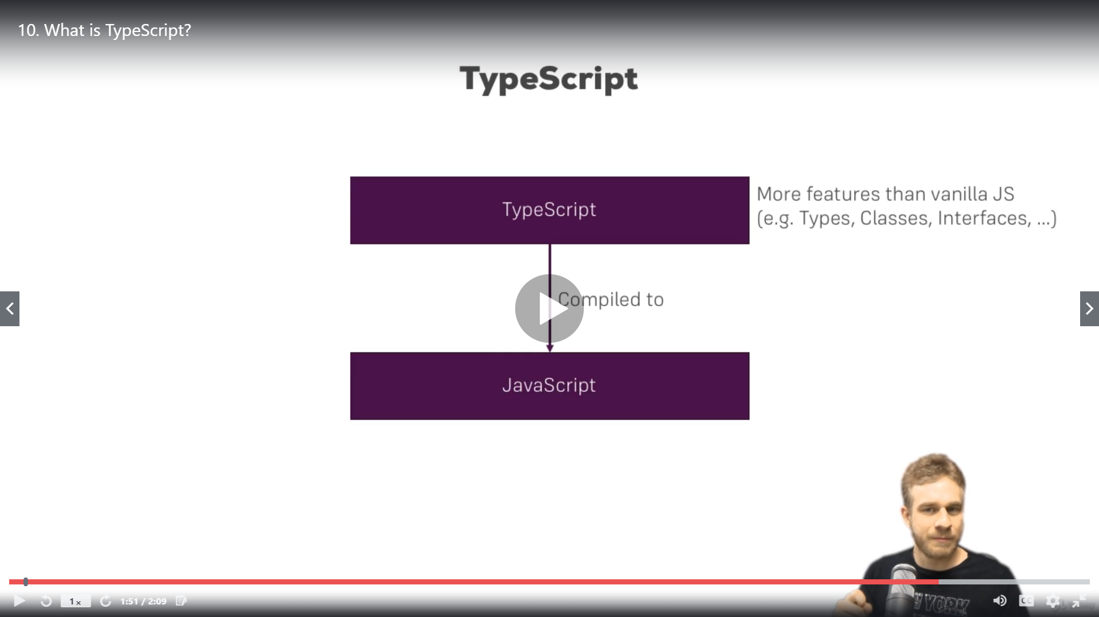

* Package .json is the most imp file it has all the dependencies

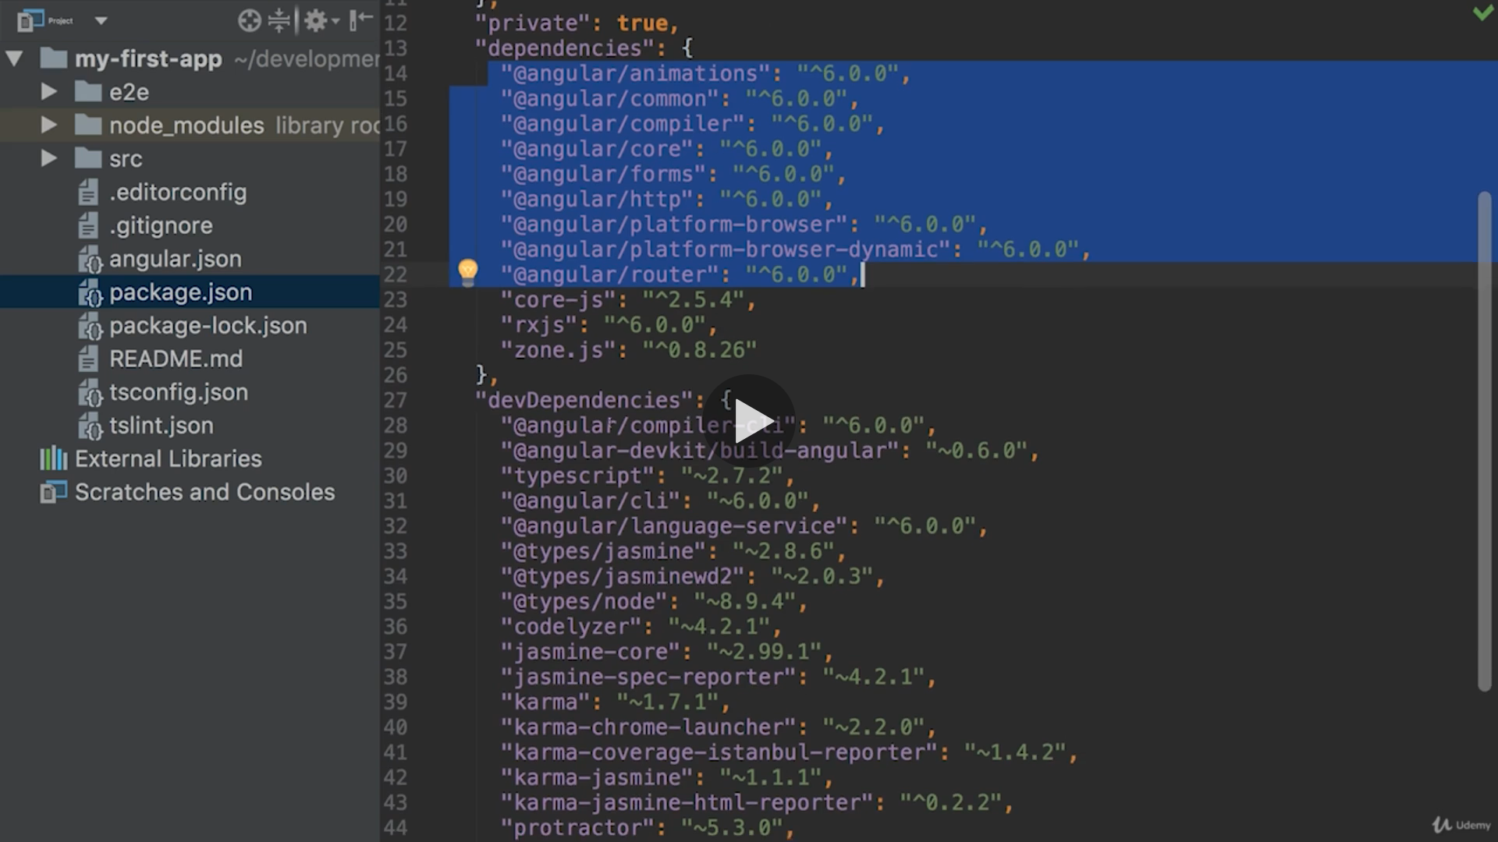

* The dev dependencies are only required for development

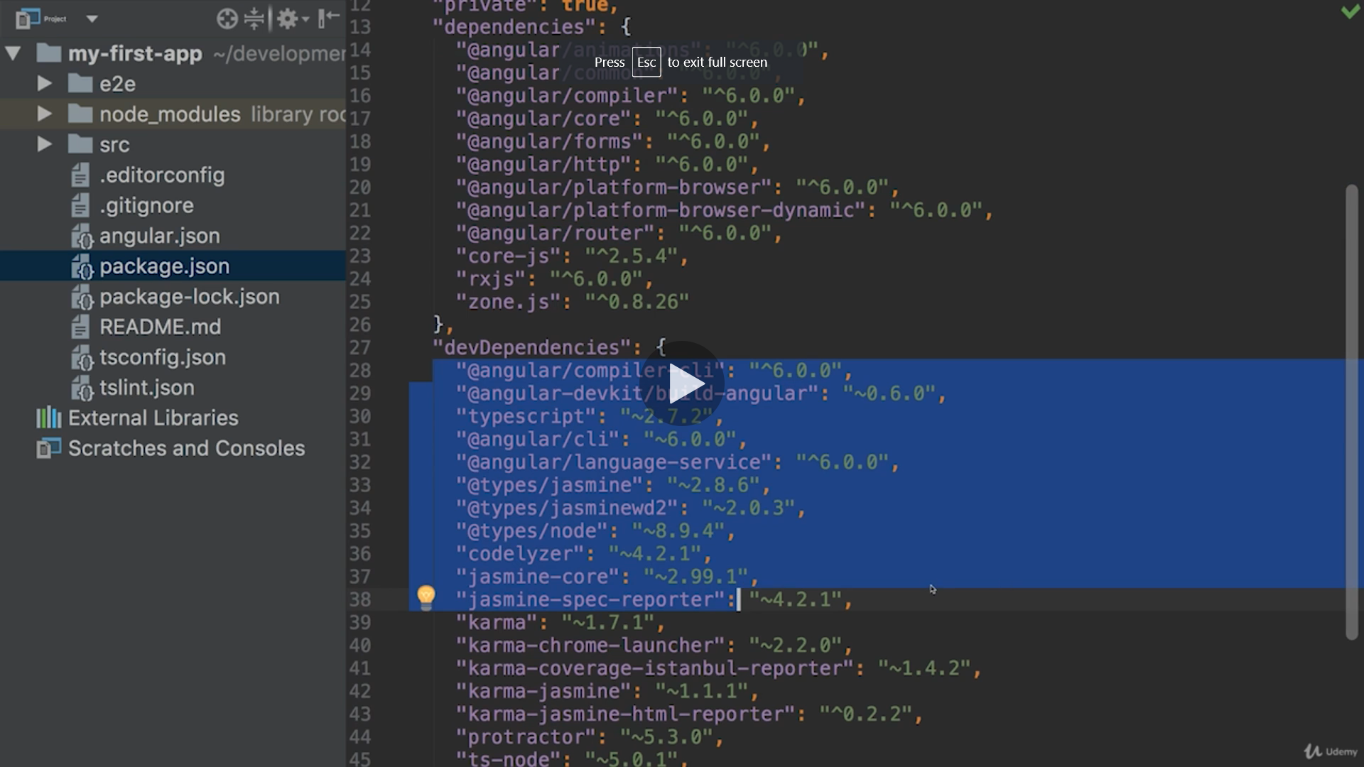

* To install bootstrap
* npm install –save bootstrap@3
* once installed we need to make entry in angular .json file in styles array

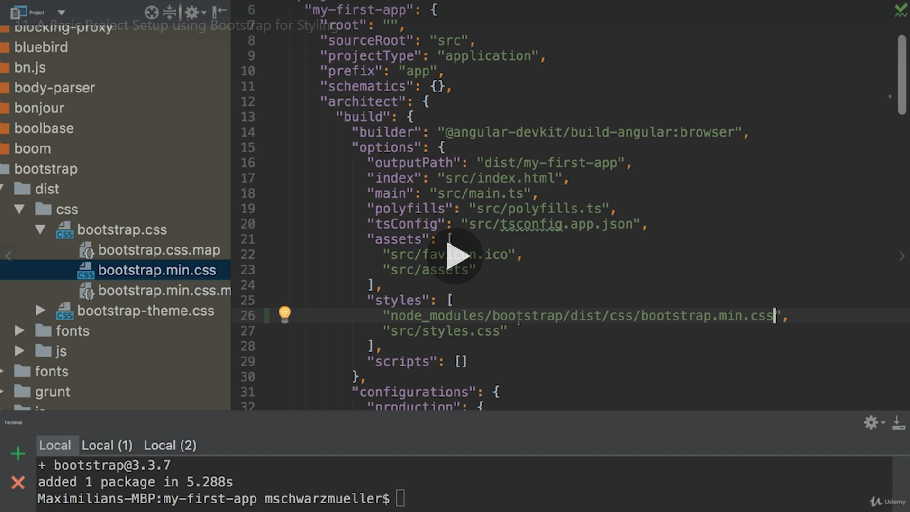

* After ng serve you can see the bootstrap In head

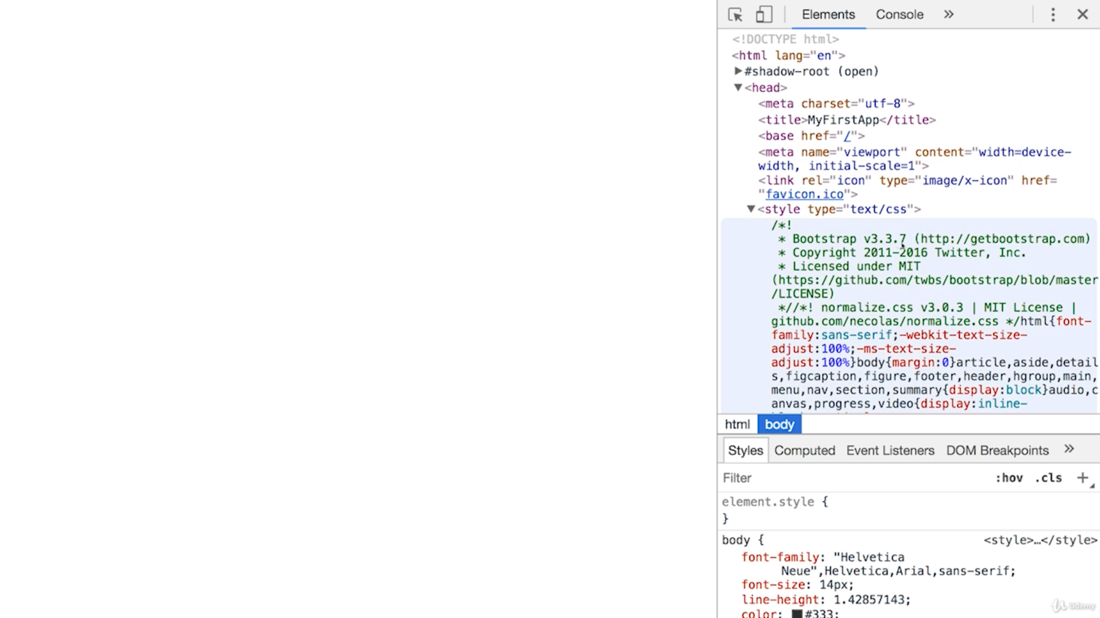

* Angular is the single page application and index.html is the only file which is loaded in the browser

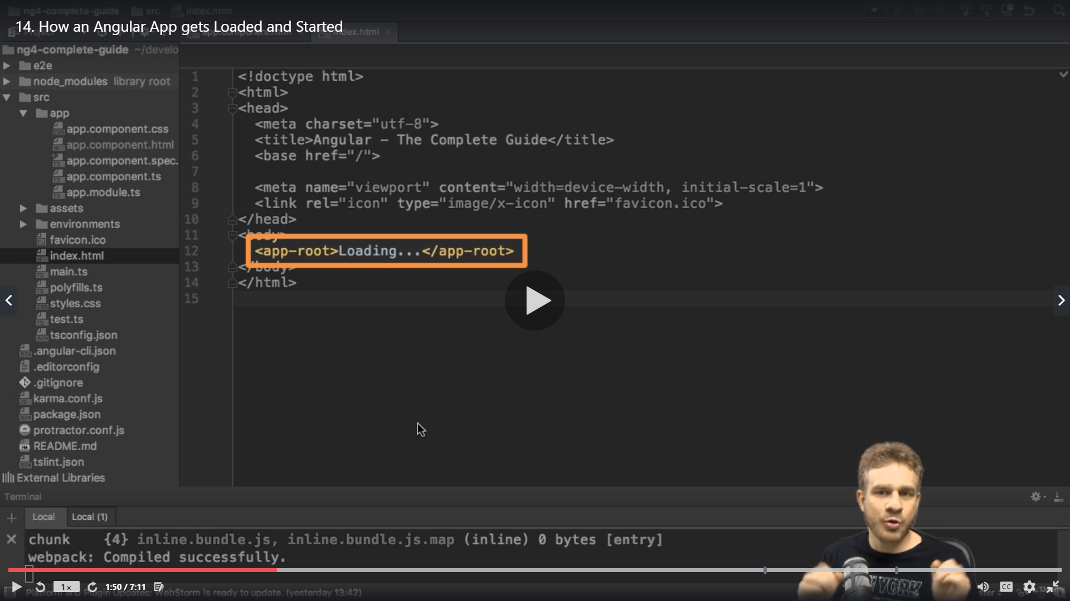

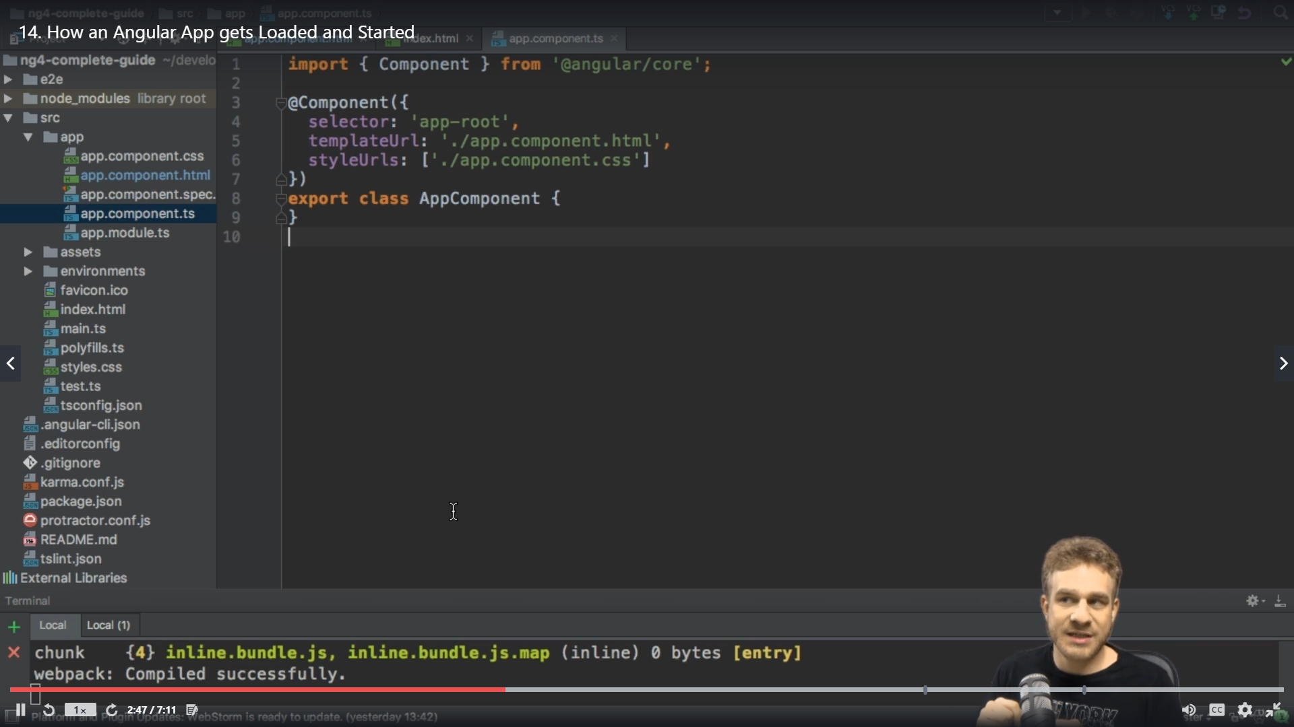

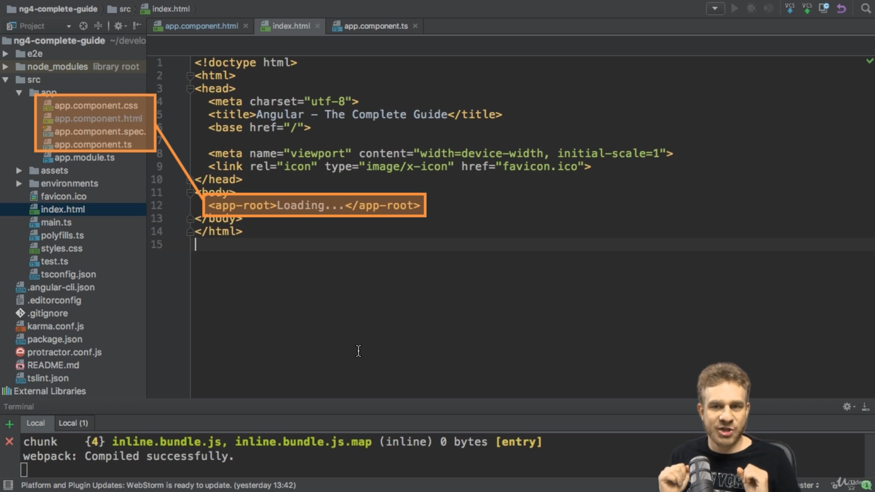

* When we do ng serve the javascript bundles are created and imports are added to the file
* Main .js the first file which is loaded in it we have Mapping of AppModule

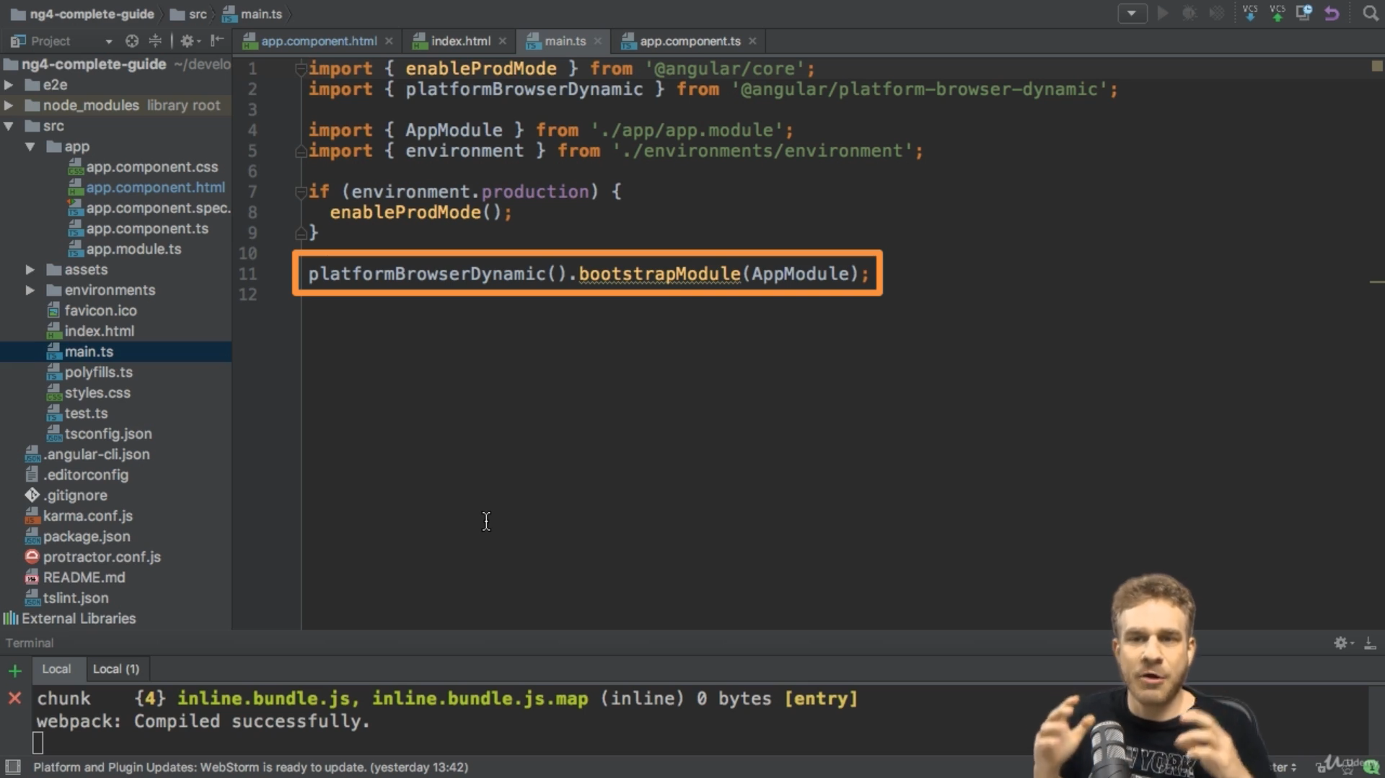

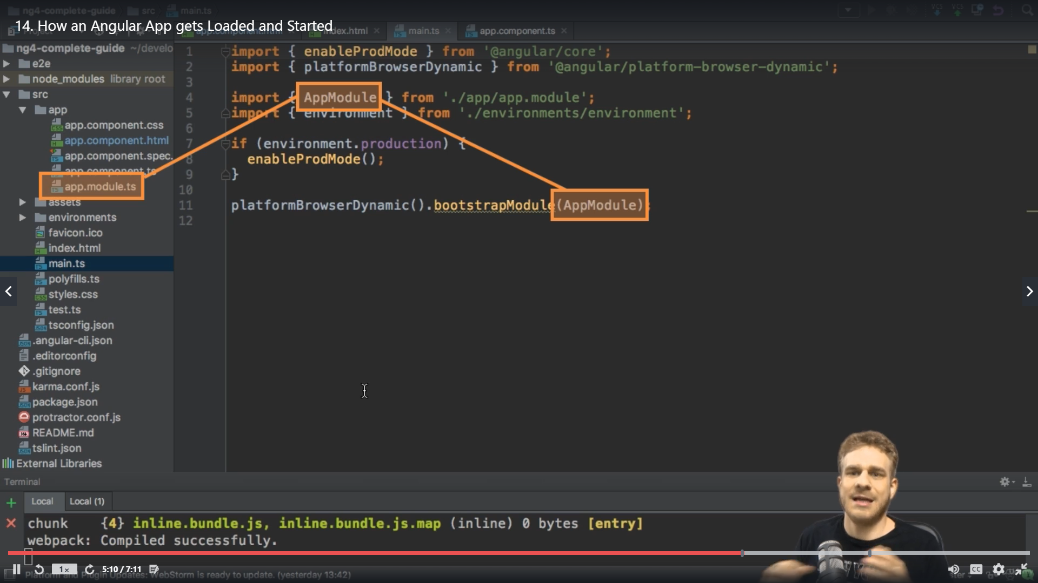

* In App component we have bootstrapping of App component

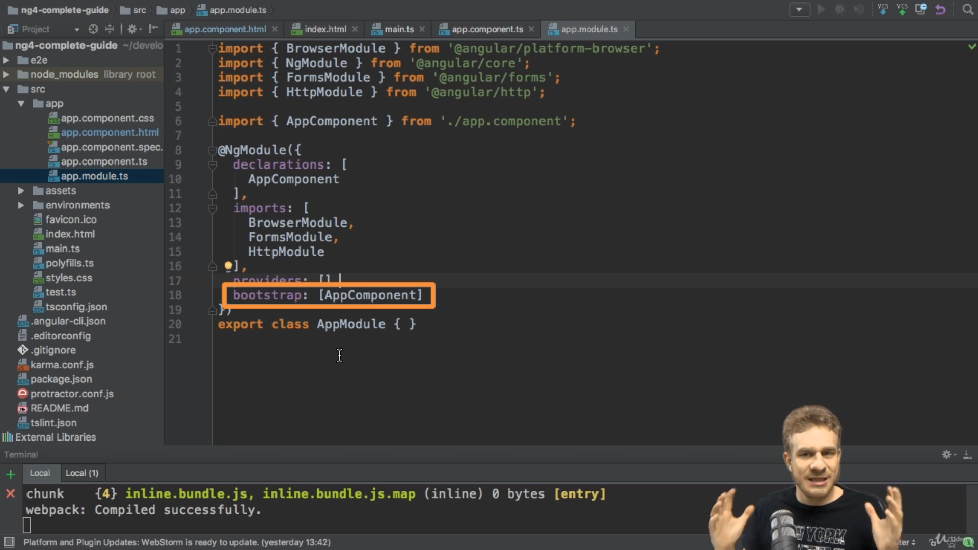

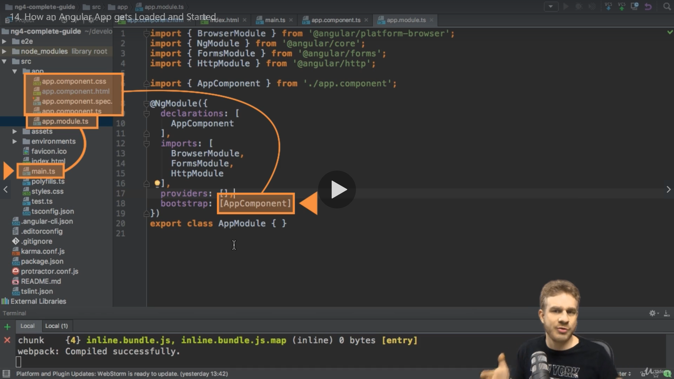

* The selector of the app.cpmponent.ts is added in the index.html



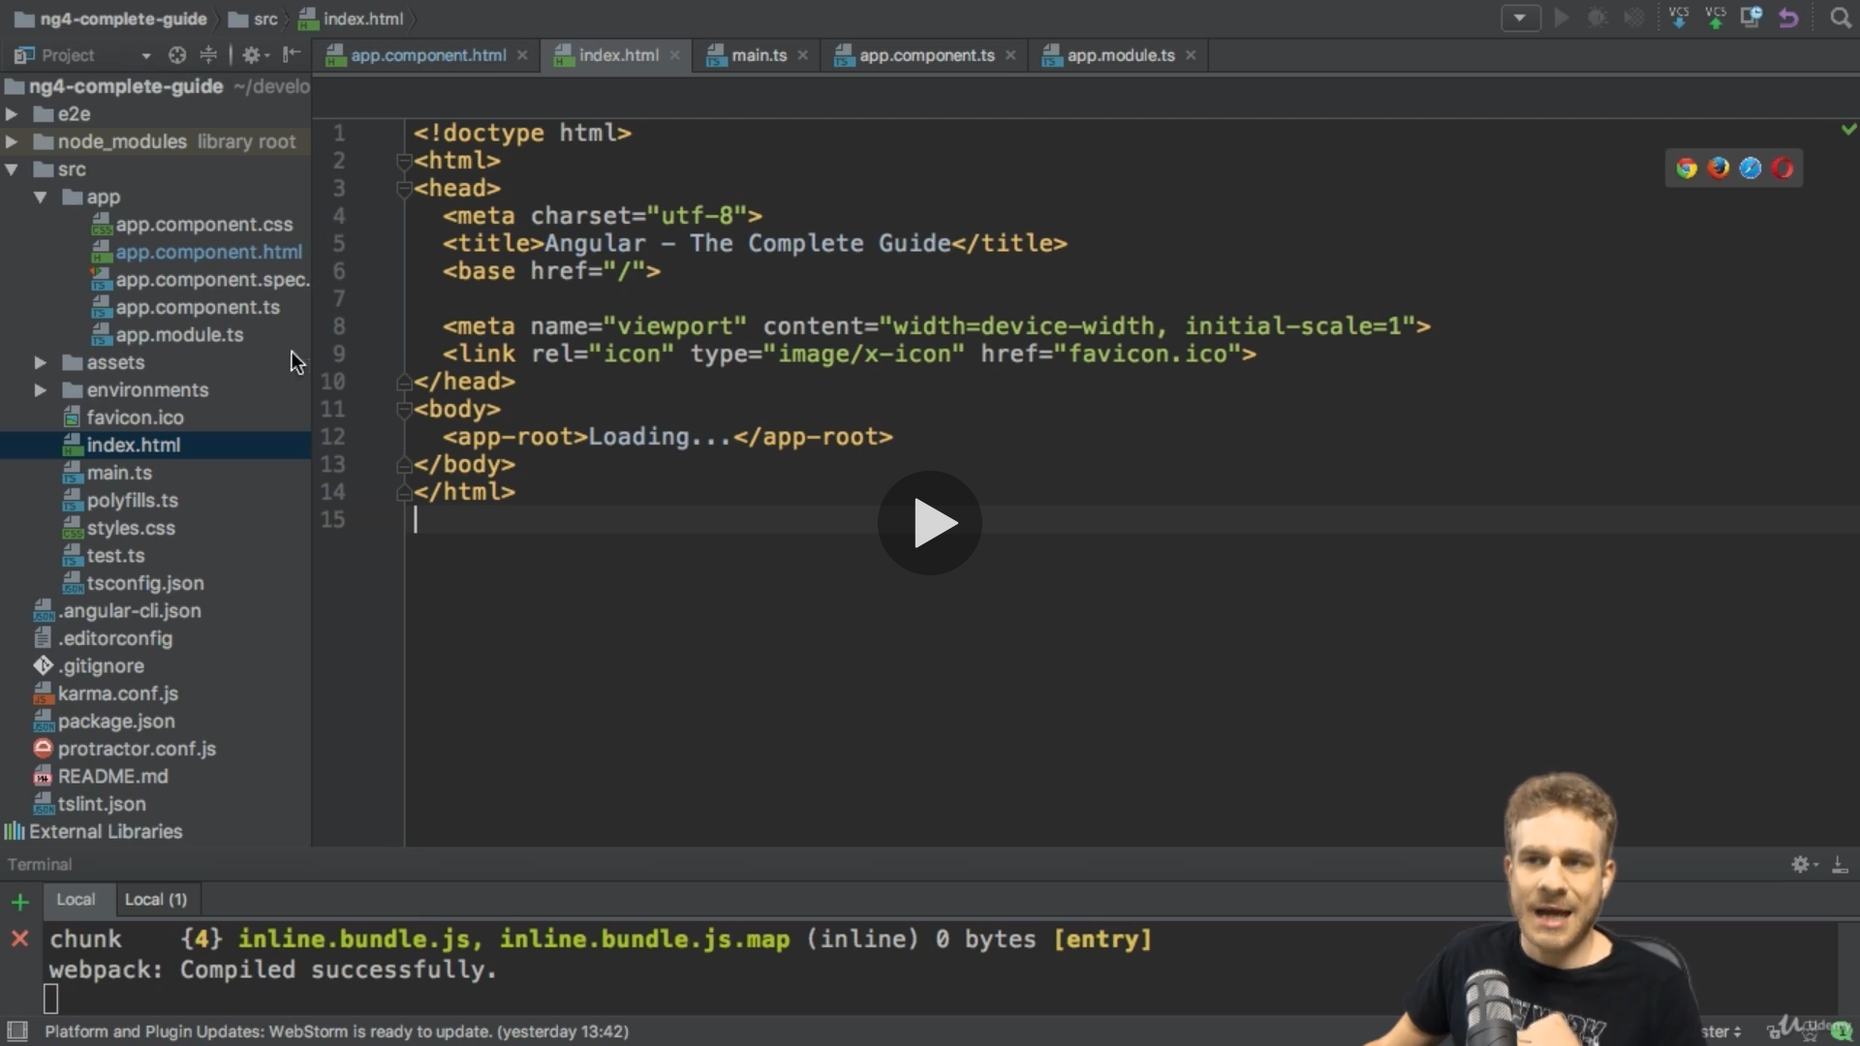

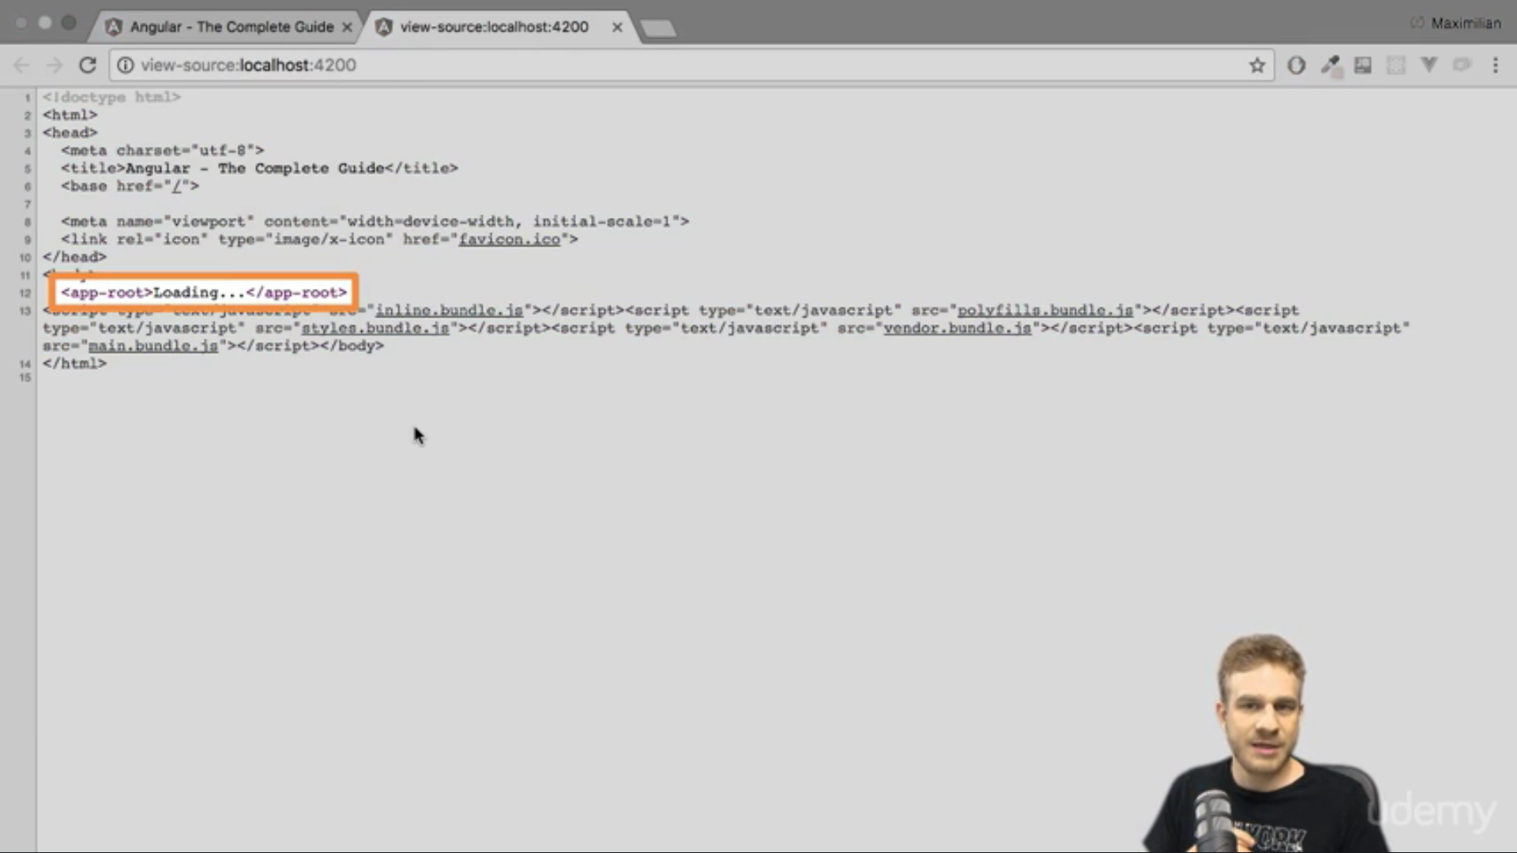

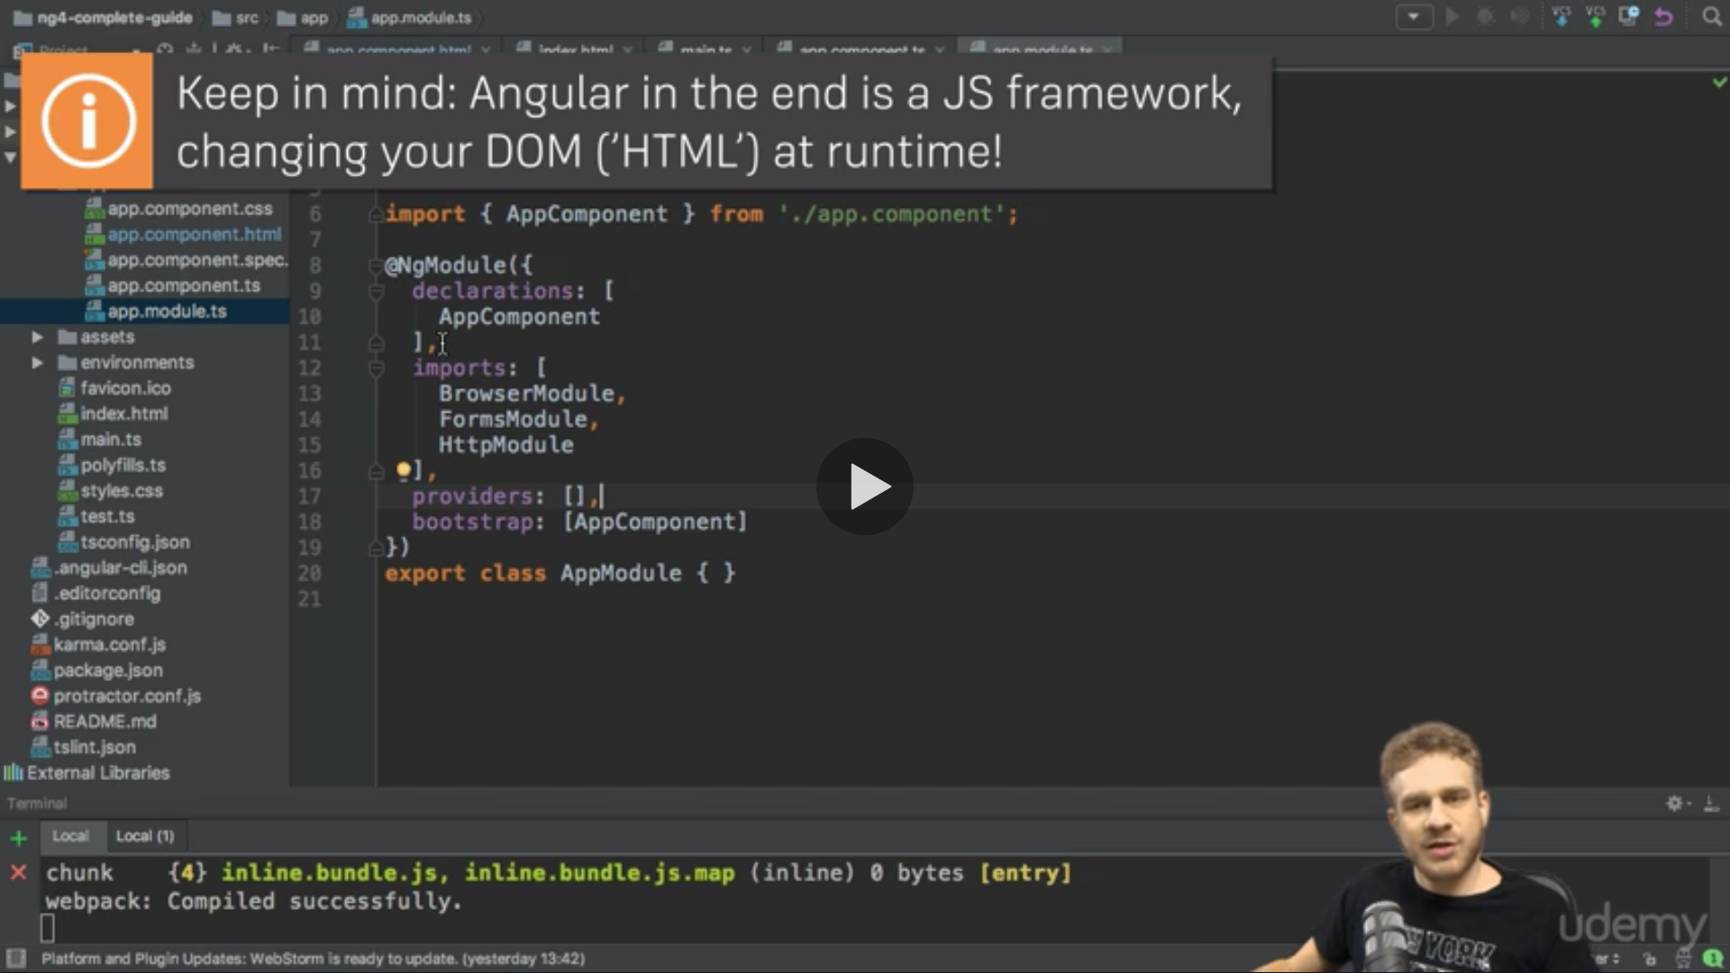

Component

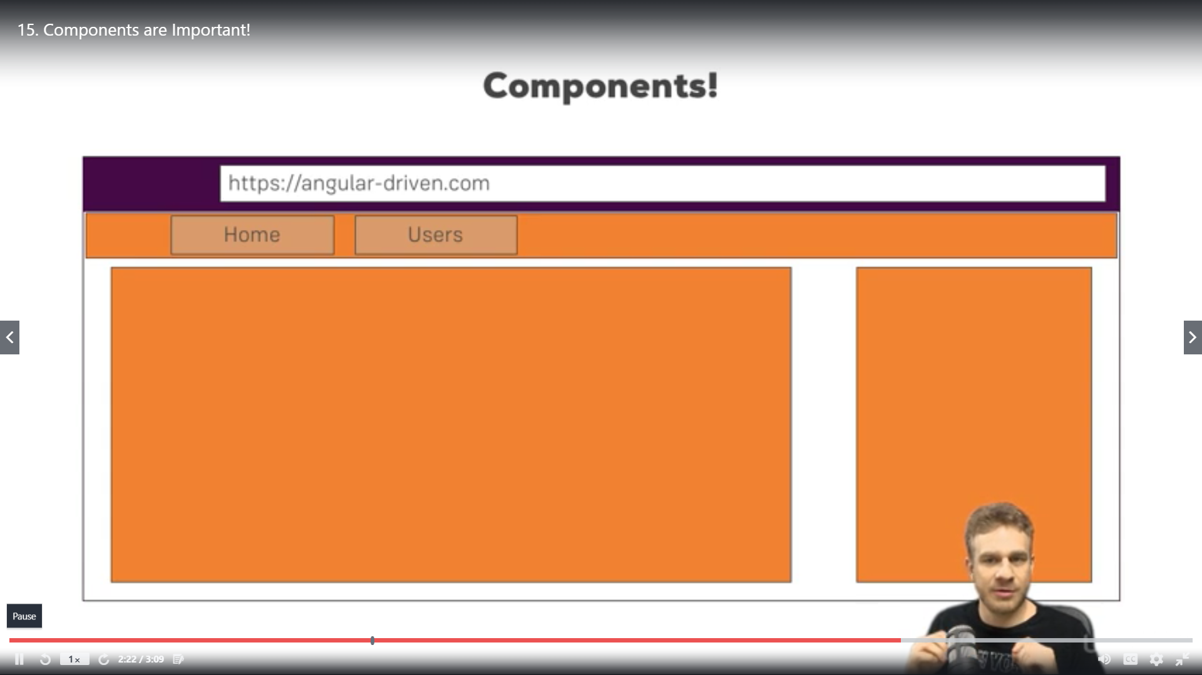

* Decorators are those which enhance your application and provide extra feature and the are denoted by @ eg @Component

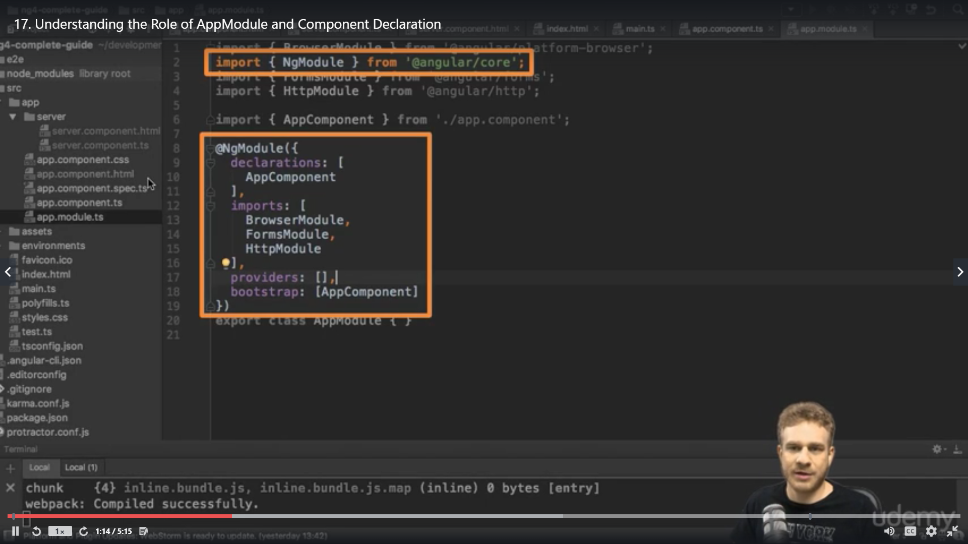

* BrowserModule gives basic functionality to start the app

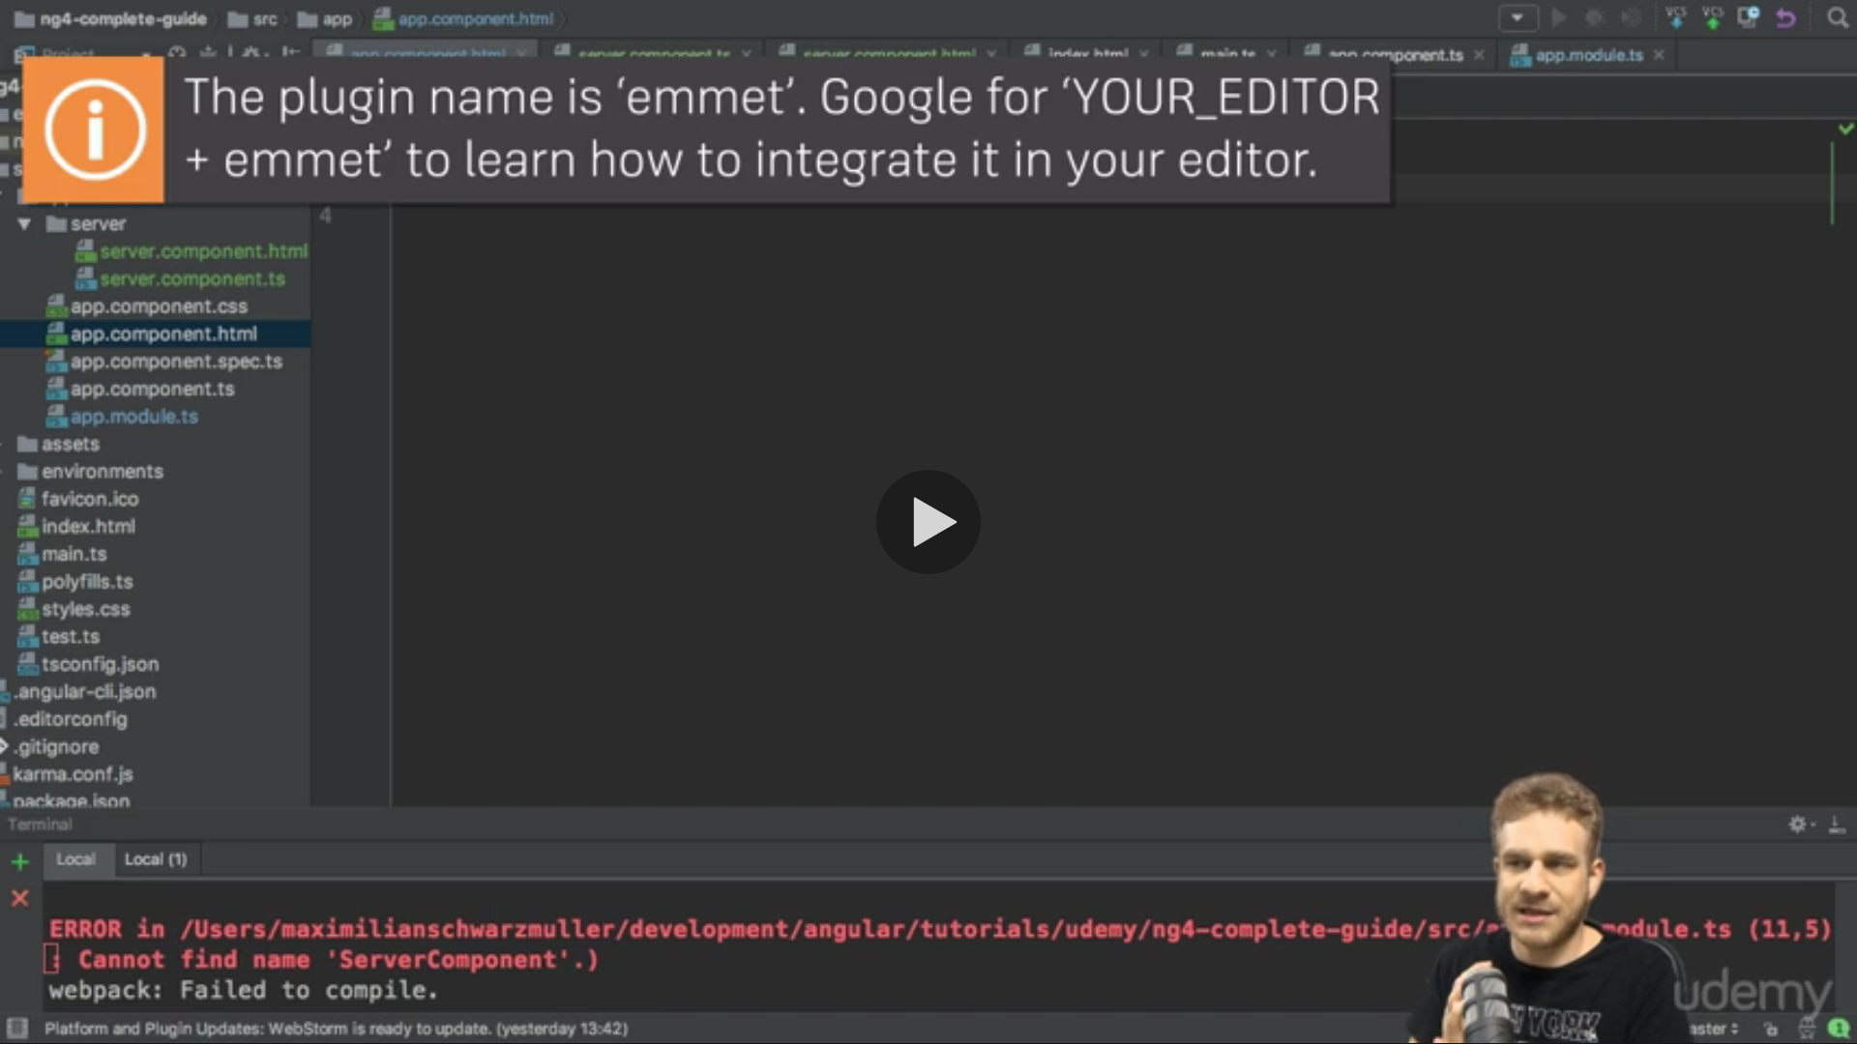

* We can use a selector tag in template as well of other component

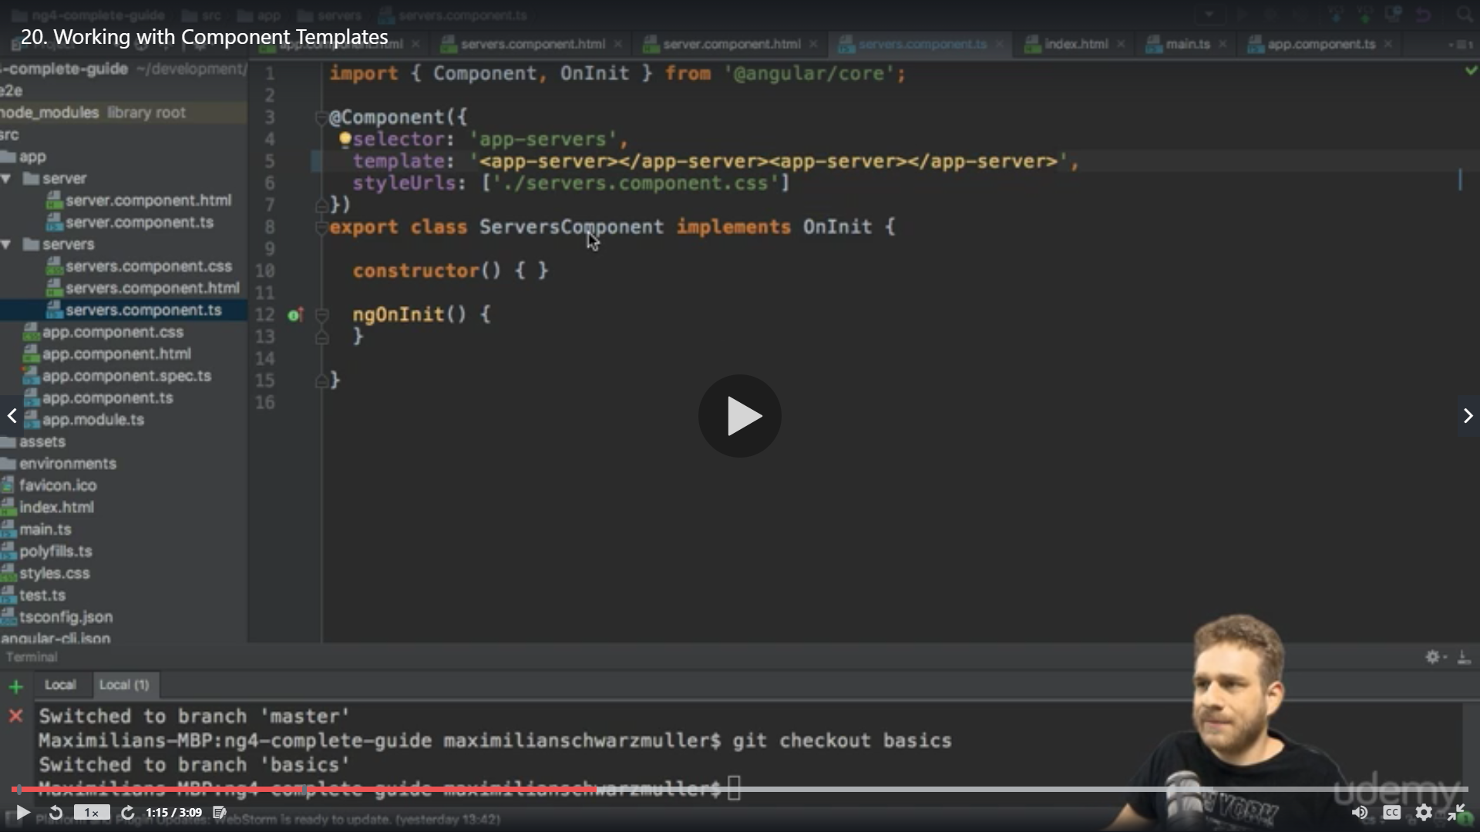

* We can write htm in template : as well just replace templateurl with template
* If we want to write multiple lines we can use ticks ‘
* Same way we can write CSS as well using ticks’’

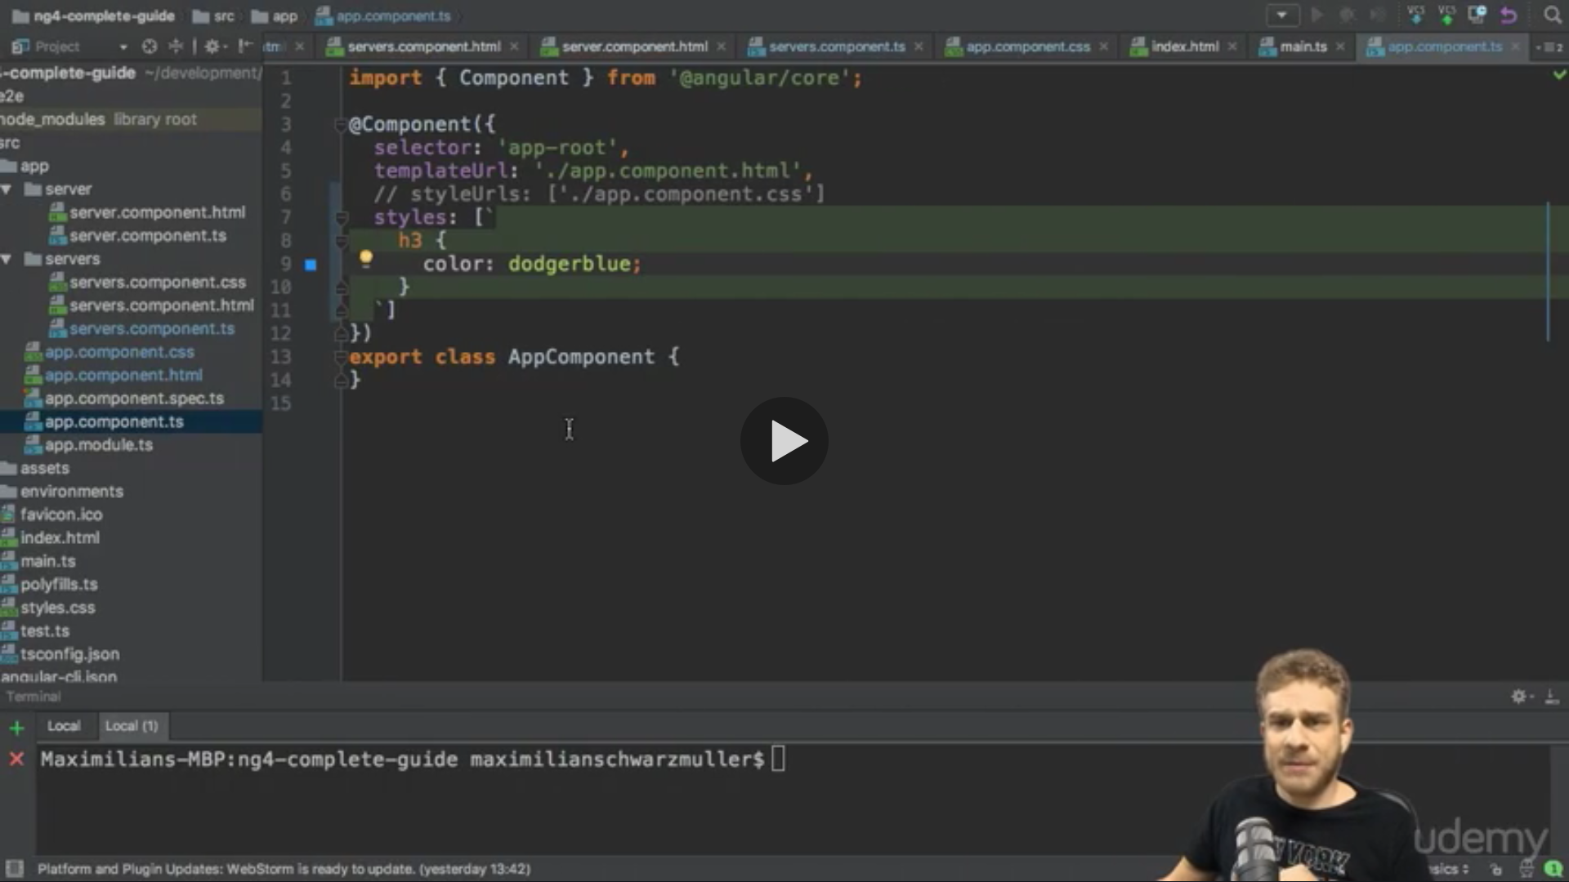

* For selectors we can mention in array as well but we need to change the tag on html

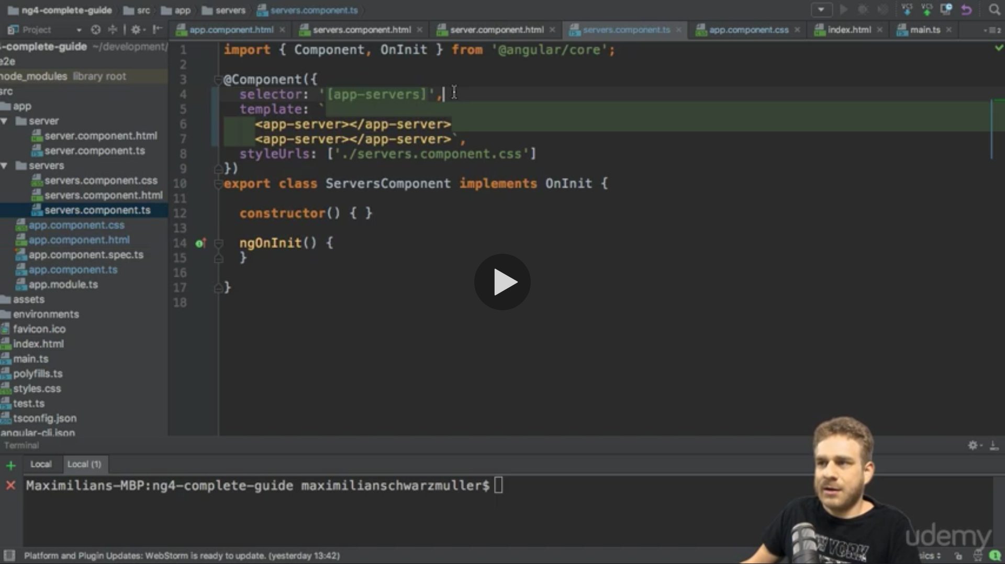

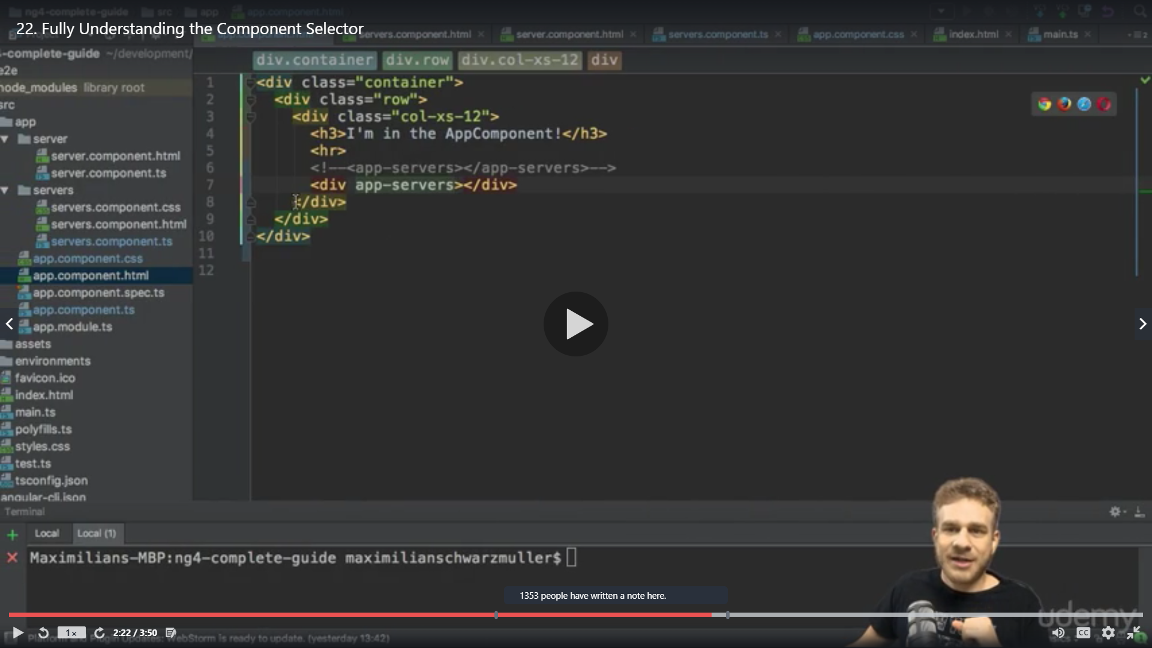

* Another alternative is to select in form of class .app-servers

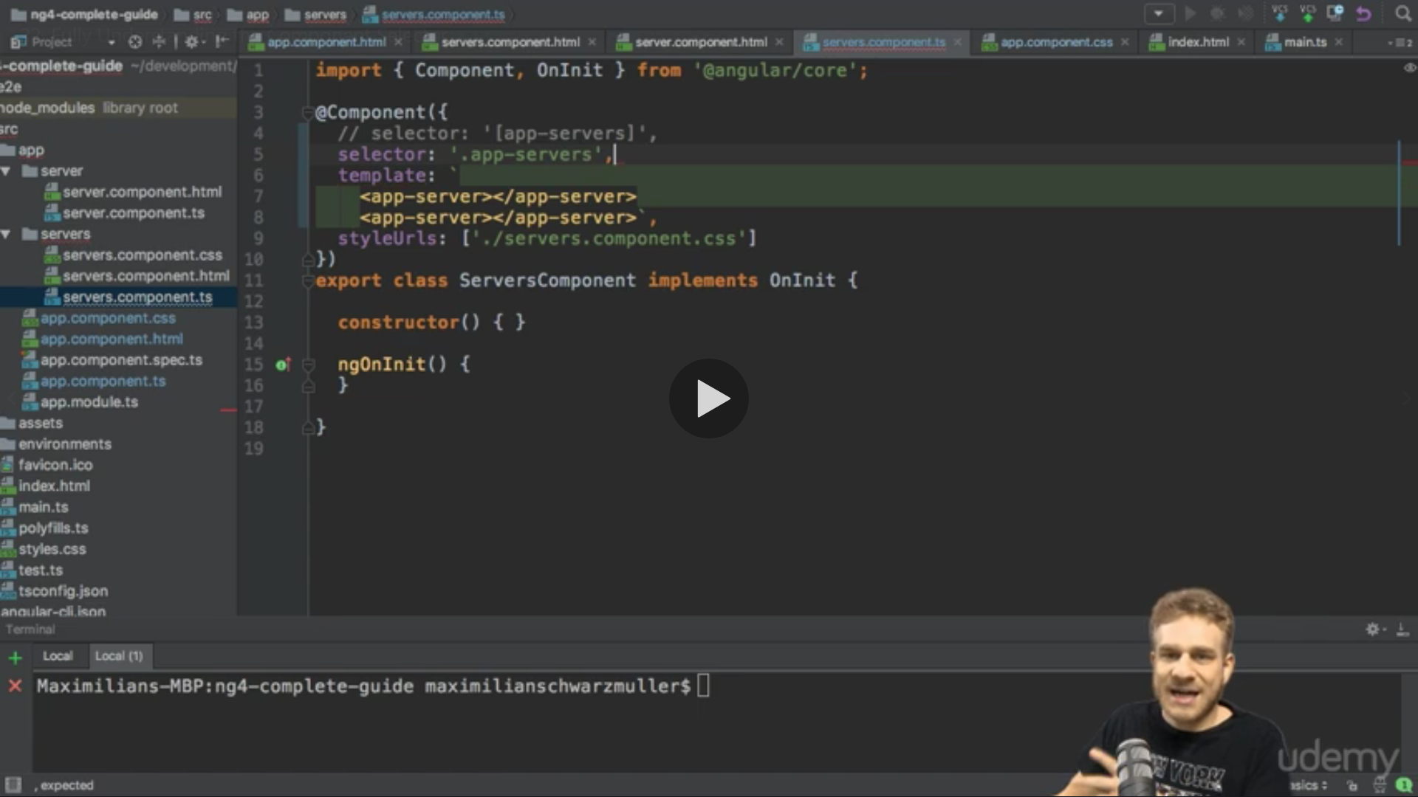

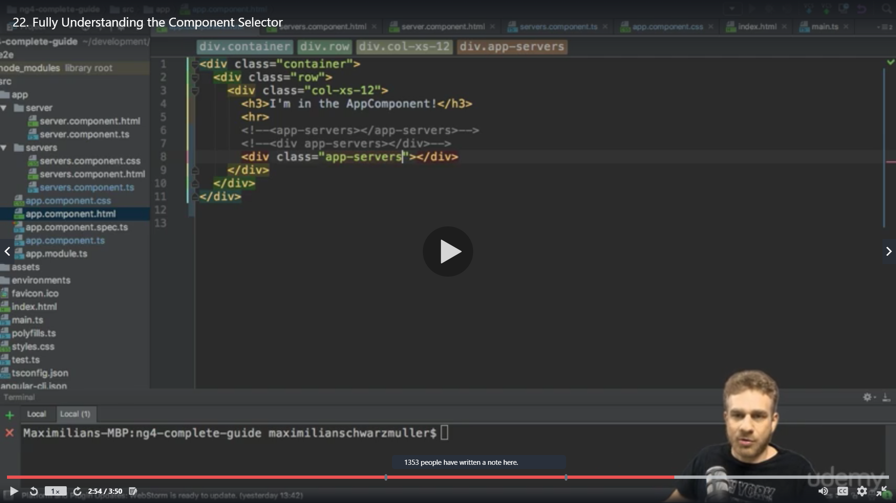

* Data Binding

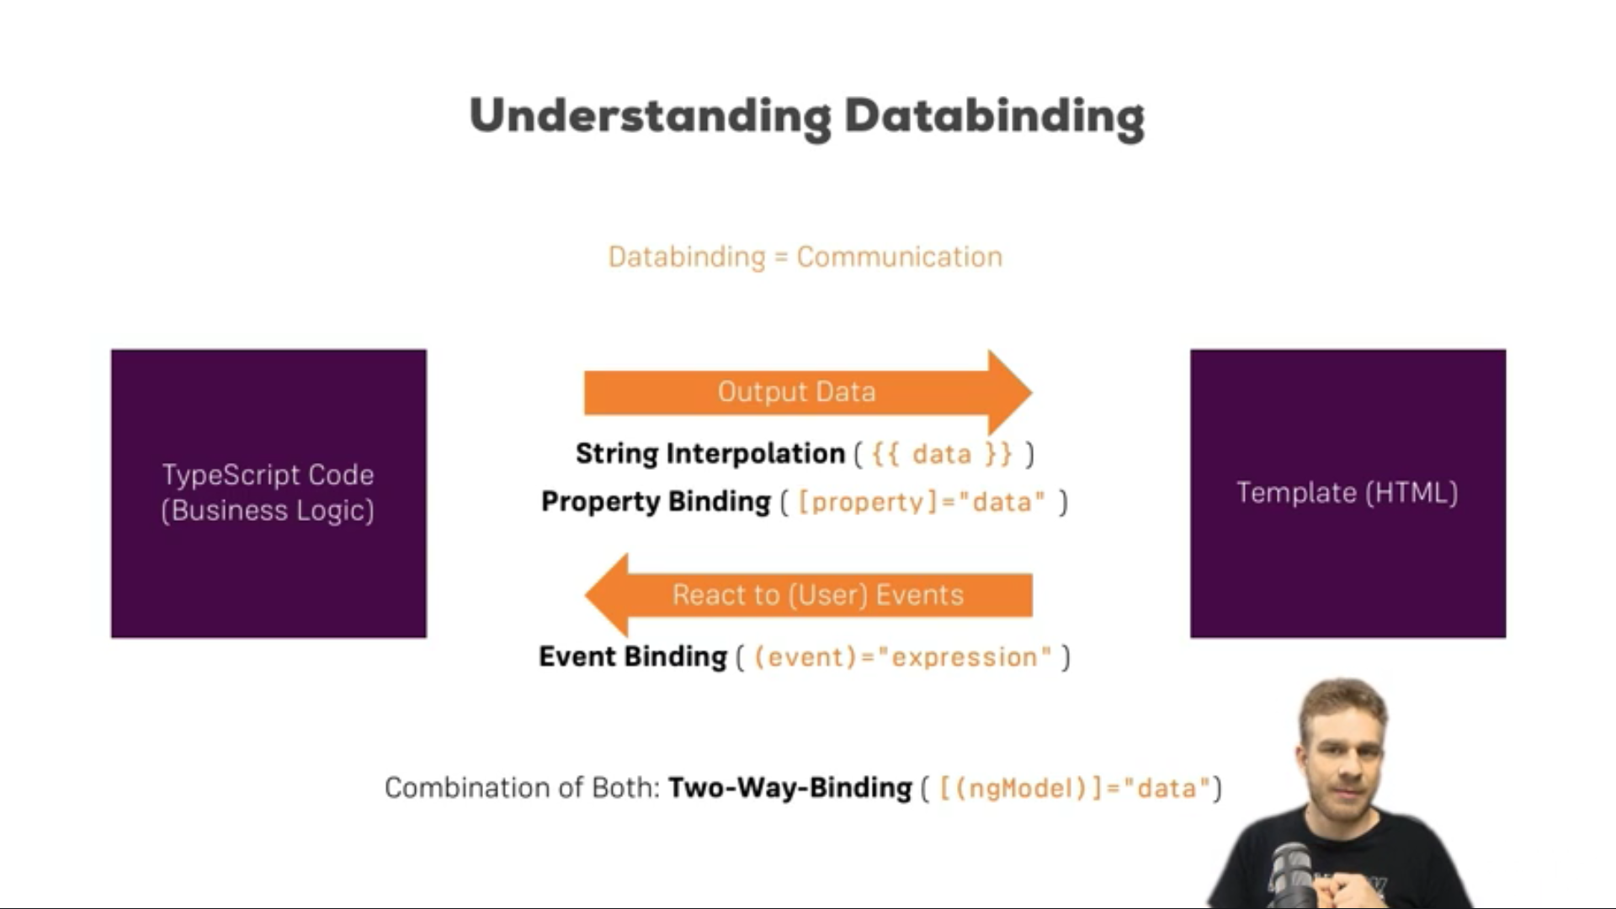

String Interpolation {{}}

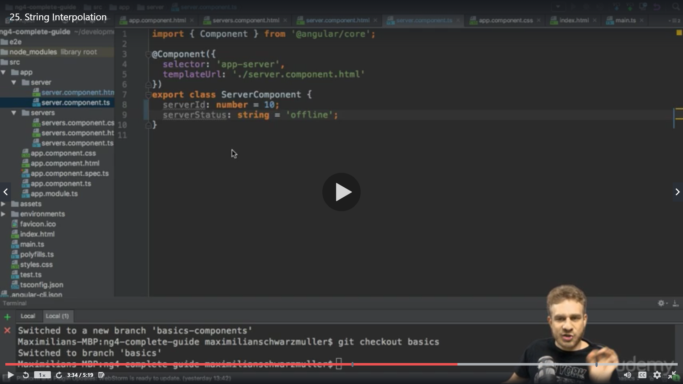

* {{‘Server ’}} is not mentioned in server.component.html anything written in {{‘’}}will be considered as string and made available for string interpolation

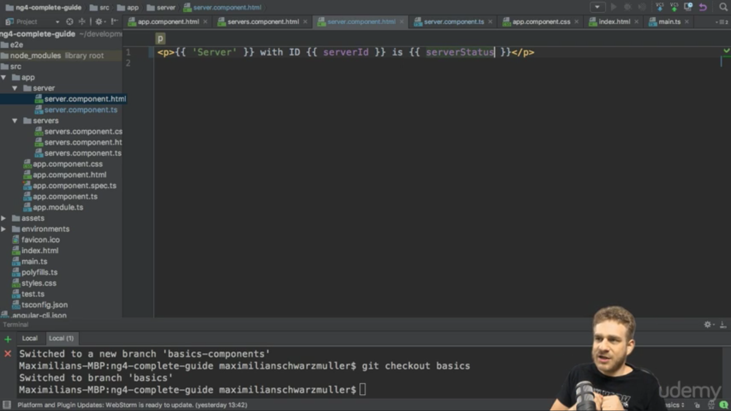

We can call a method as well as it returns a string

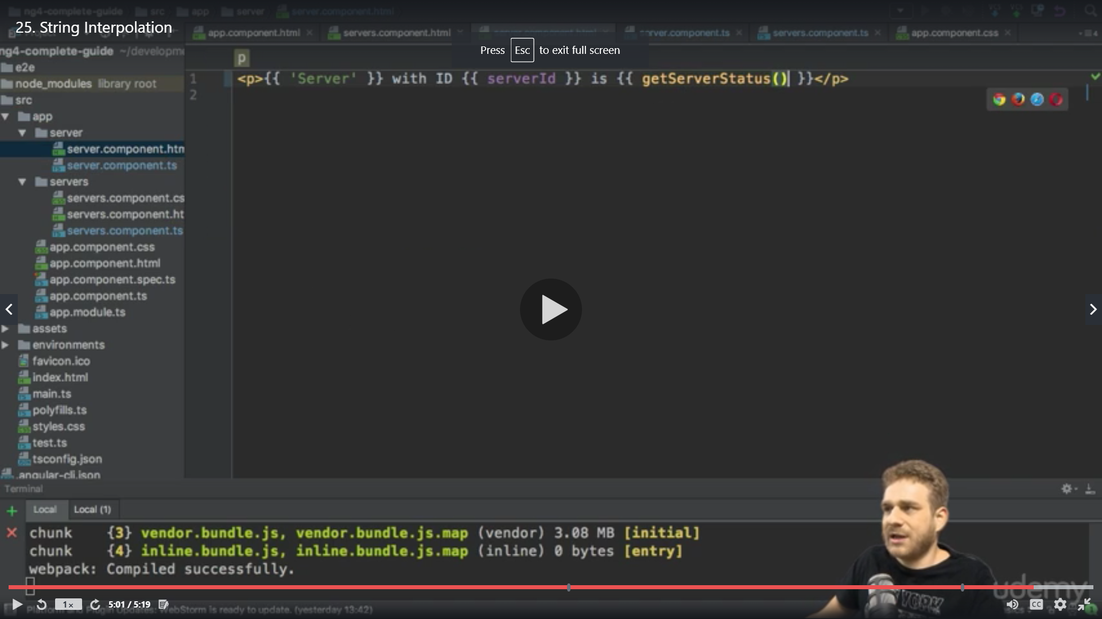

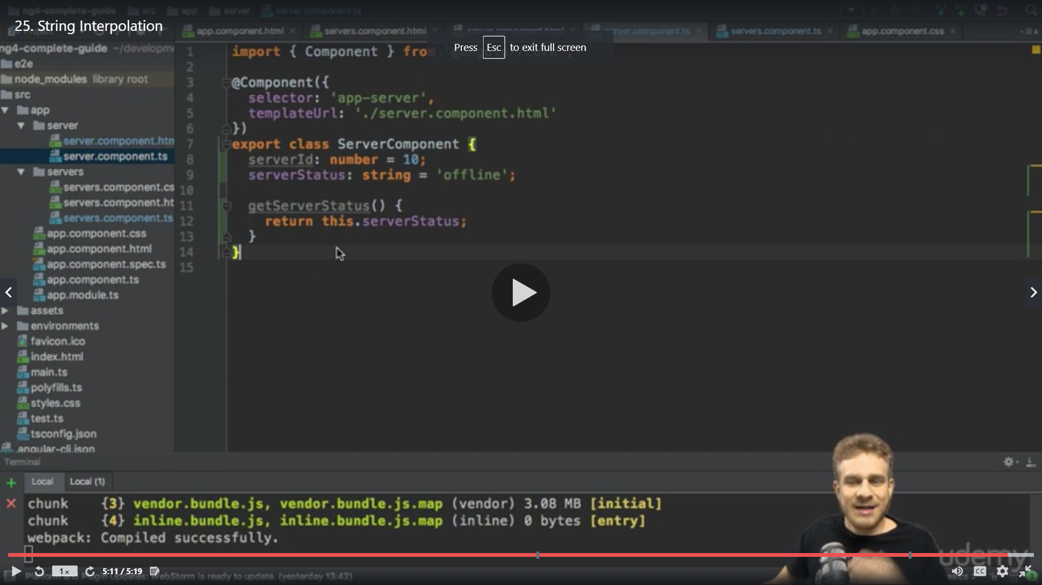

Property binding []

We are adding a button initialy its disabled and after 2 seconds it should be available

We define javascript function setTimeout

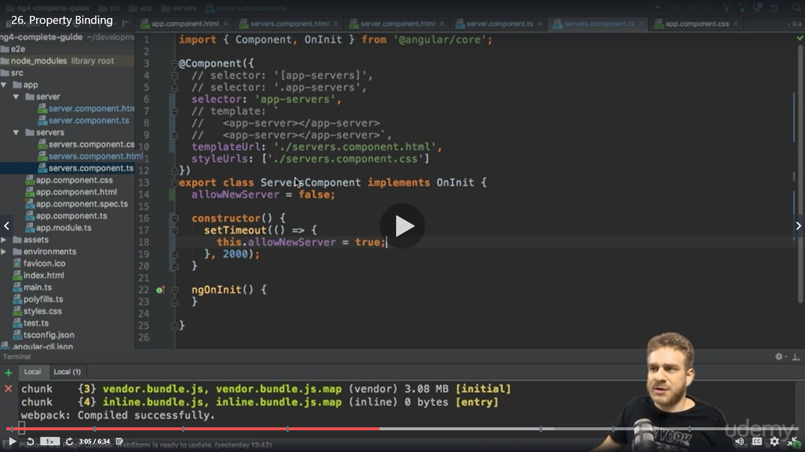

setTimeout(()=>{this.allowNewServer=true},2000);

Initially our button was just disabled <button **disabled** class="btn btn-primary">Add server</button>

So we added [disabled] to make it dynamic , the disable is an attribute which gets stored in DOM when the html loads so in order to make it dynamic we add []

The square bracket [] indicate that we are binding some property dynamically

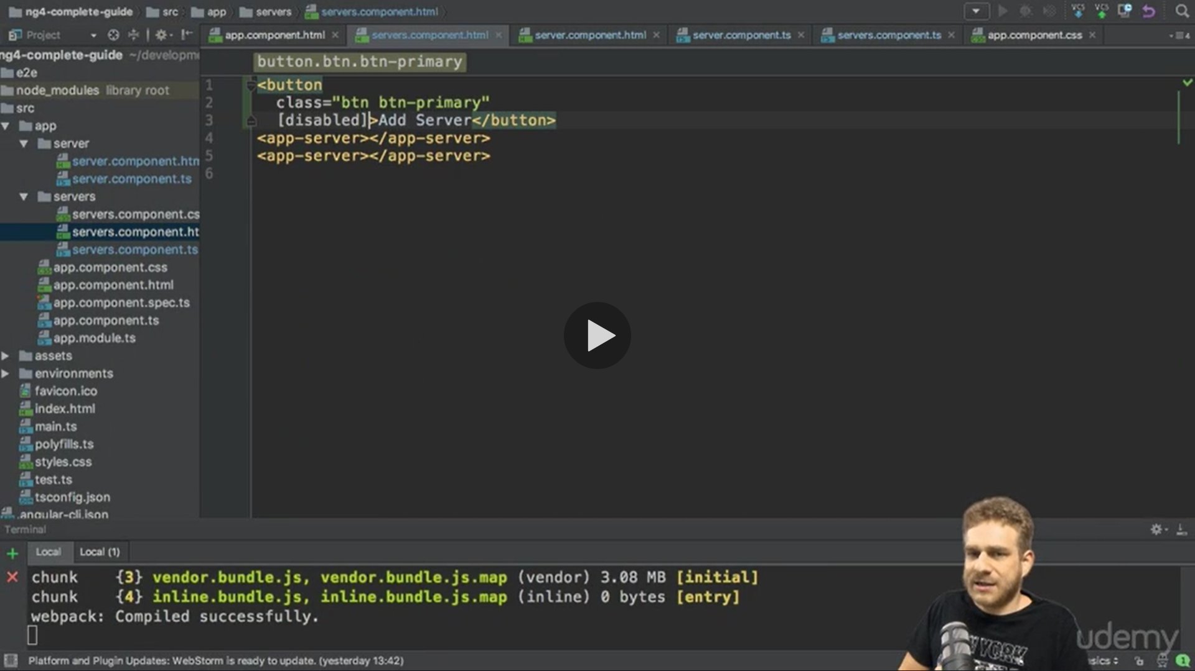

We pass our property name allowNewServer

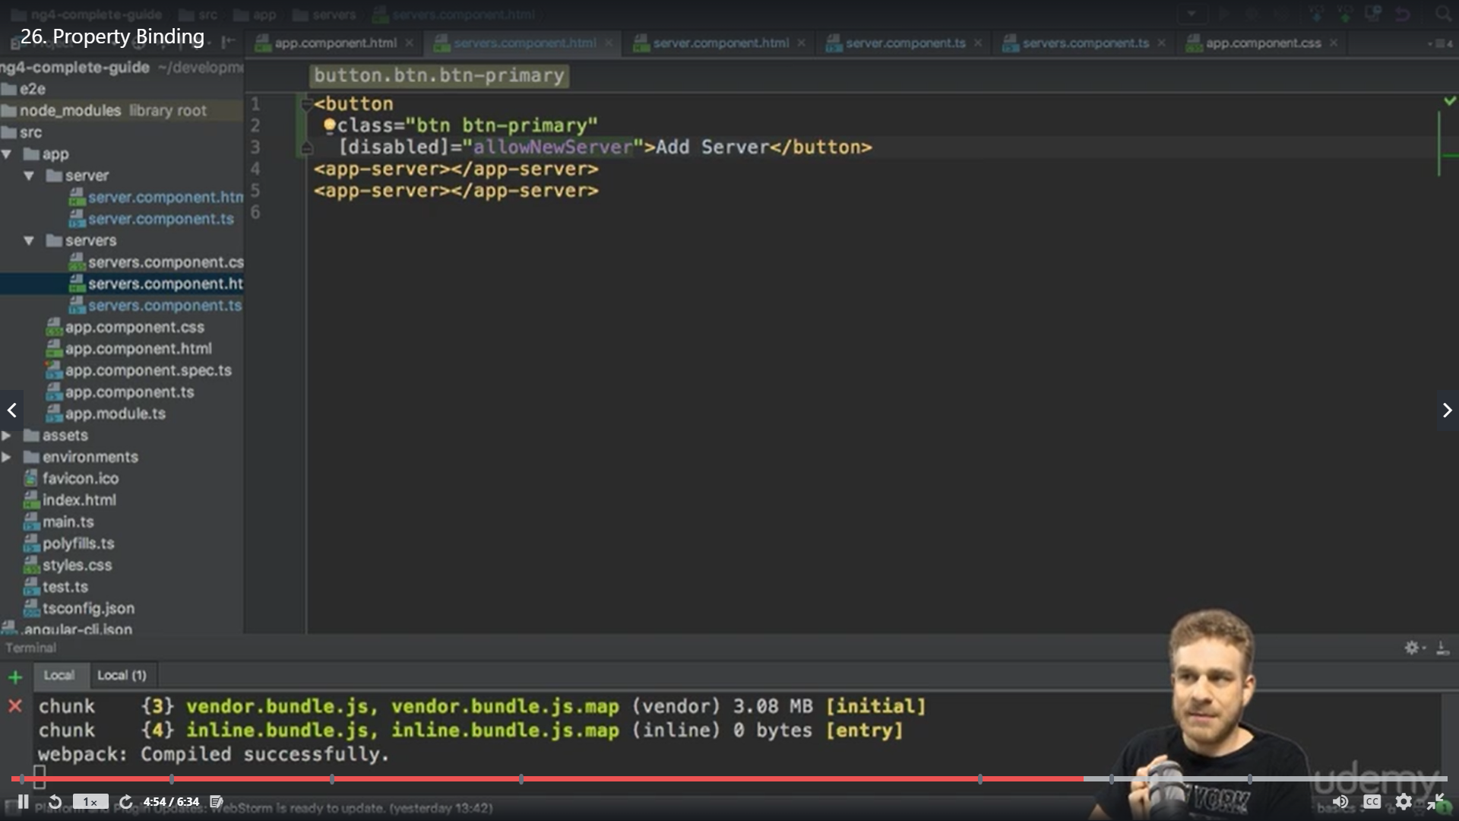

We provide condition to disable button only if the property is false

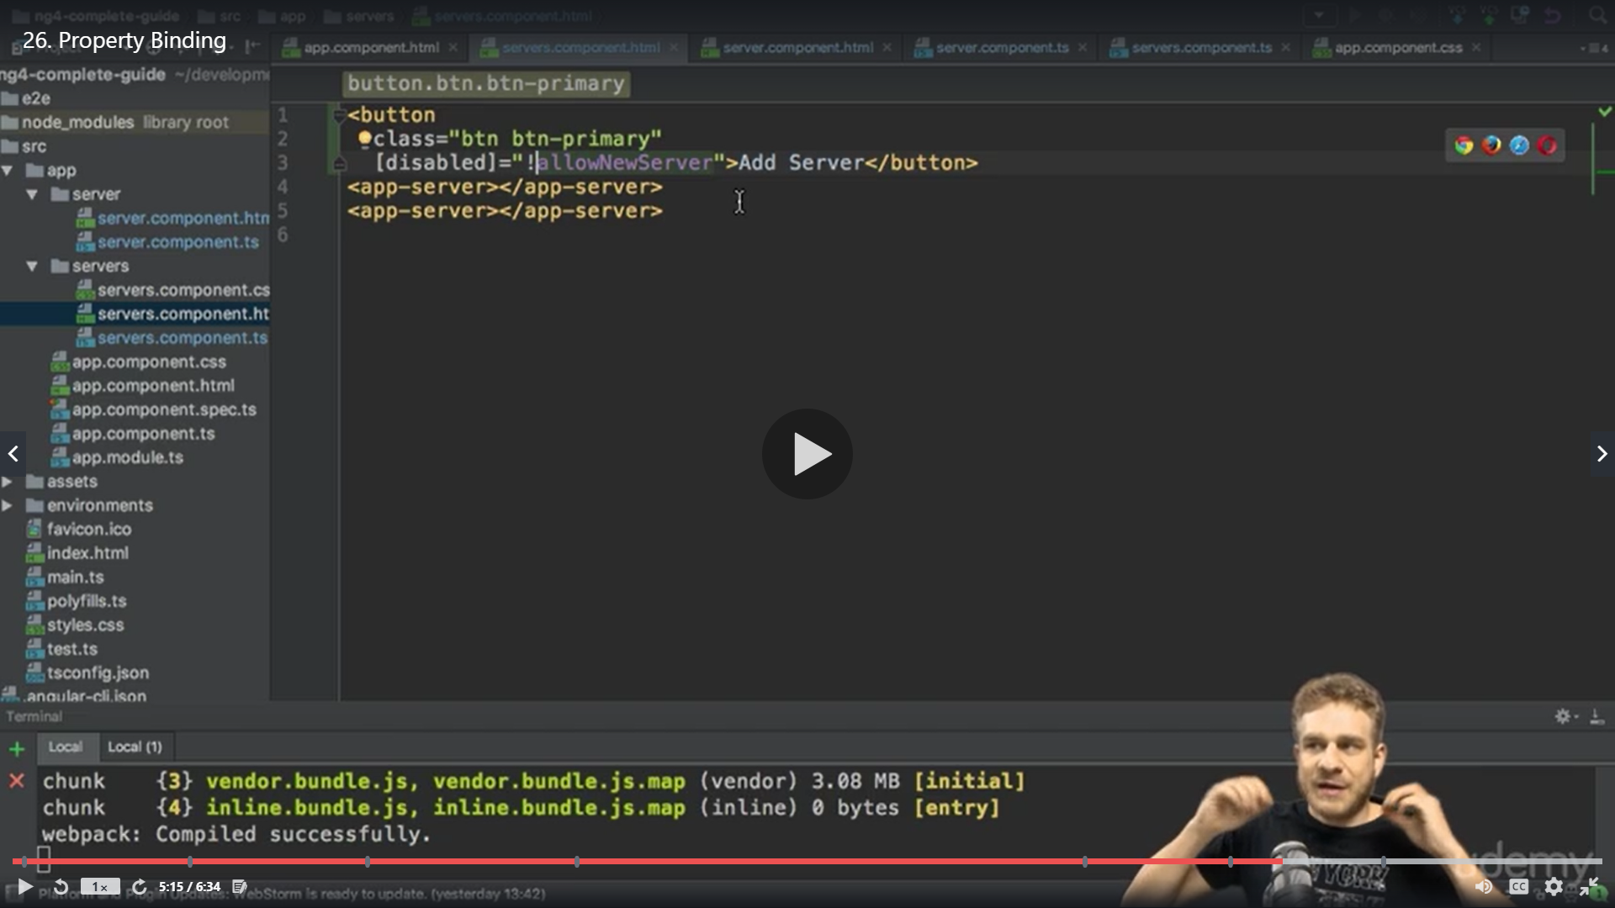

Now the button gets availble agter 2 second after the app is loaded

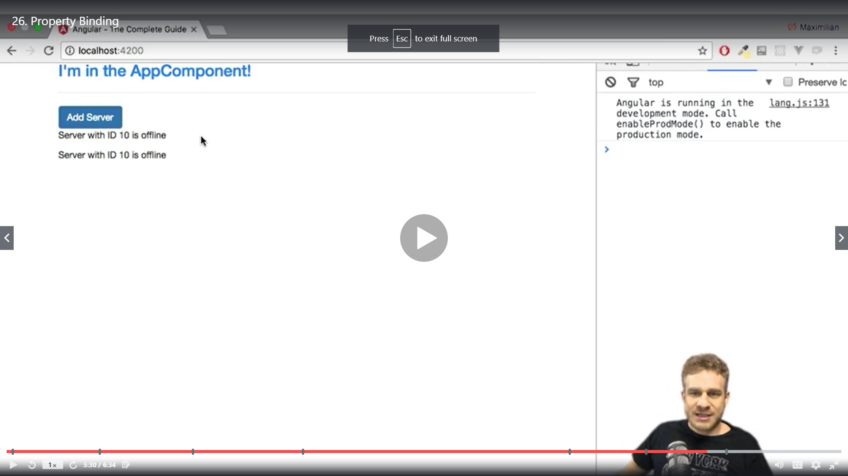

Advantage of angular is that it makes it very easy to interact with DOM and change attibutes dynamically

String interpolation VS property binding

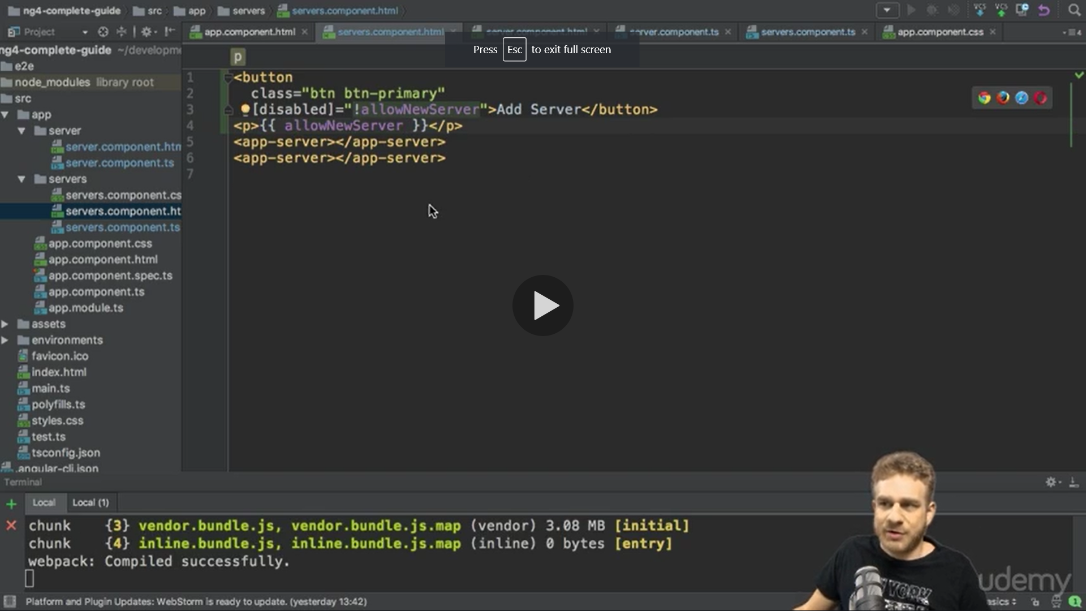

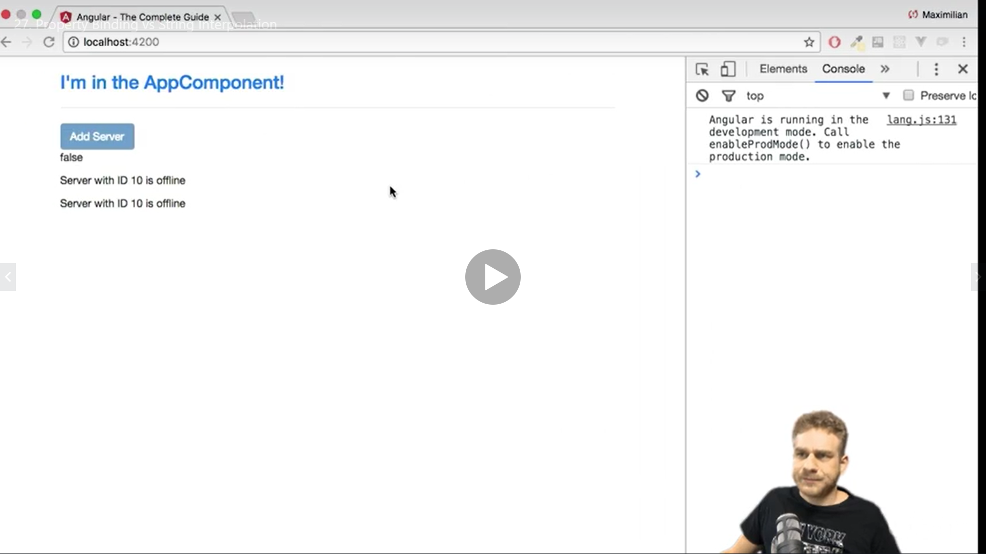

We can use inner property

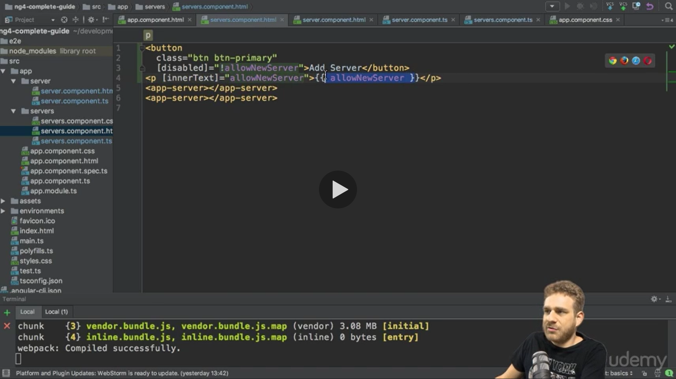

And remove the string interpolation

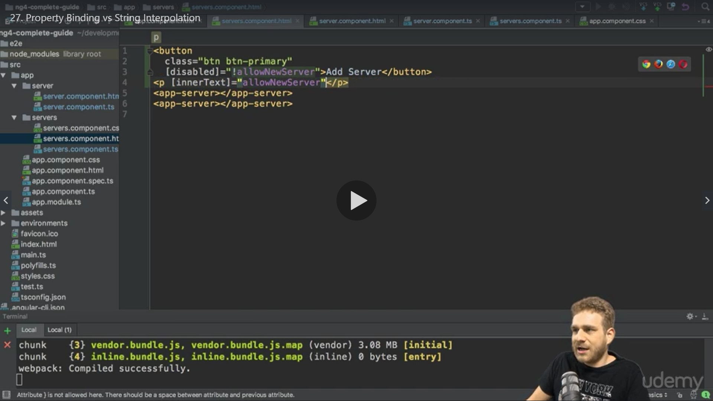

<button class="btn btn-success" [disabled]="!allowNewServer">Add Server</button>

<p>{{allowNewServer}}</p>

Same

<p [innerText]="allowNewServer"></p>

Here we replaced string interpolation with property binding

The [innerText ] captures all between “ ” eg "allowNewServer"

Use string interpolation {{}} when you want to just show something

Eg: <p>{{allowNewServer}}</p>

Use property binding [] u want to change any property or directive dynamically

Eg: <button class="btn btn-success" [disabled]="!allowNewServer">Add Server</button>

Note :

Never use property bindinga and string interpolation together

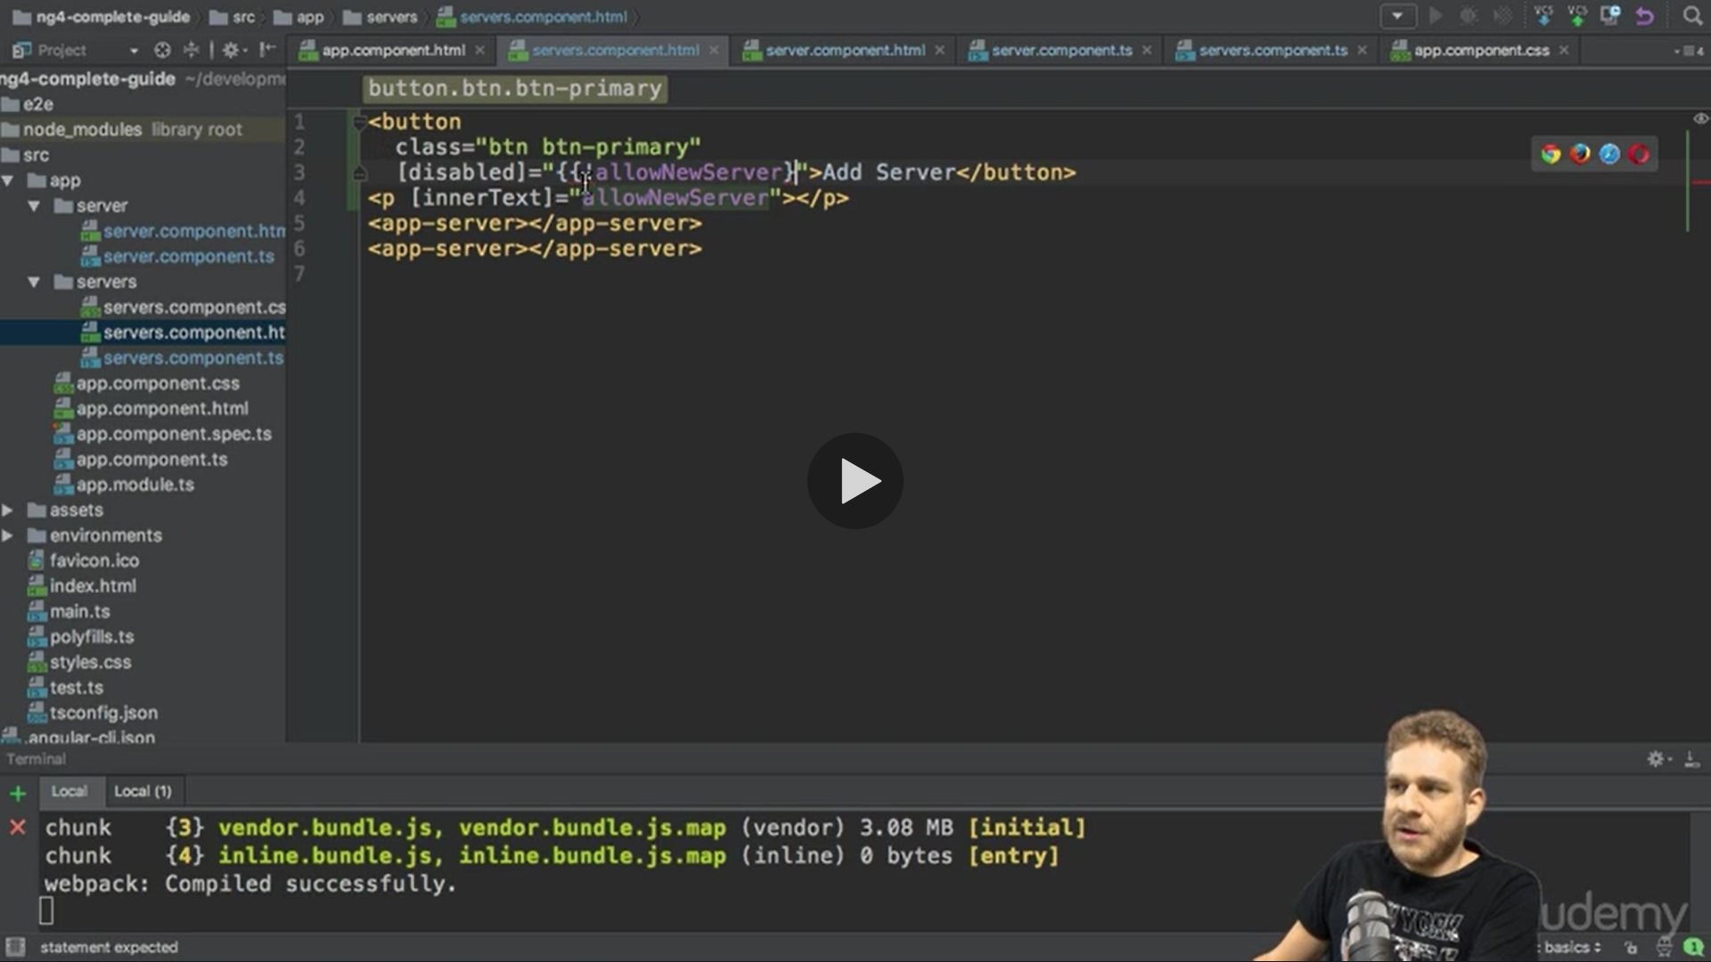

The below syntax is recognized by angular so never use string interpolation between “ ” mixing string interpolation “{{ }}” will break the syntax

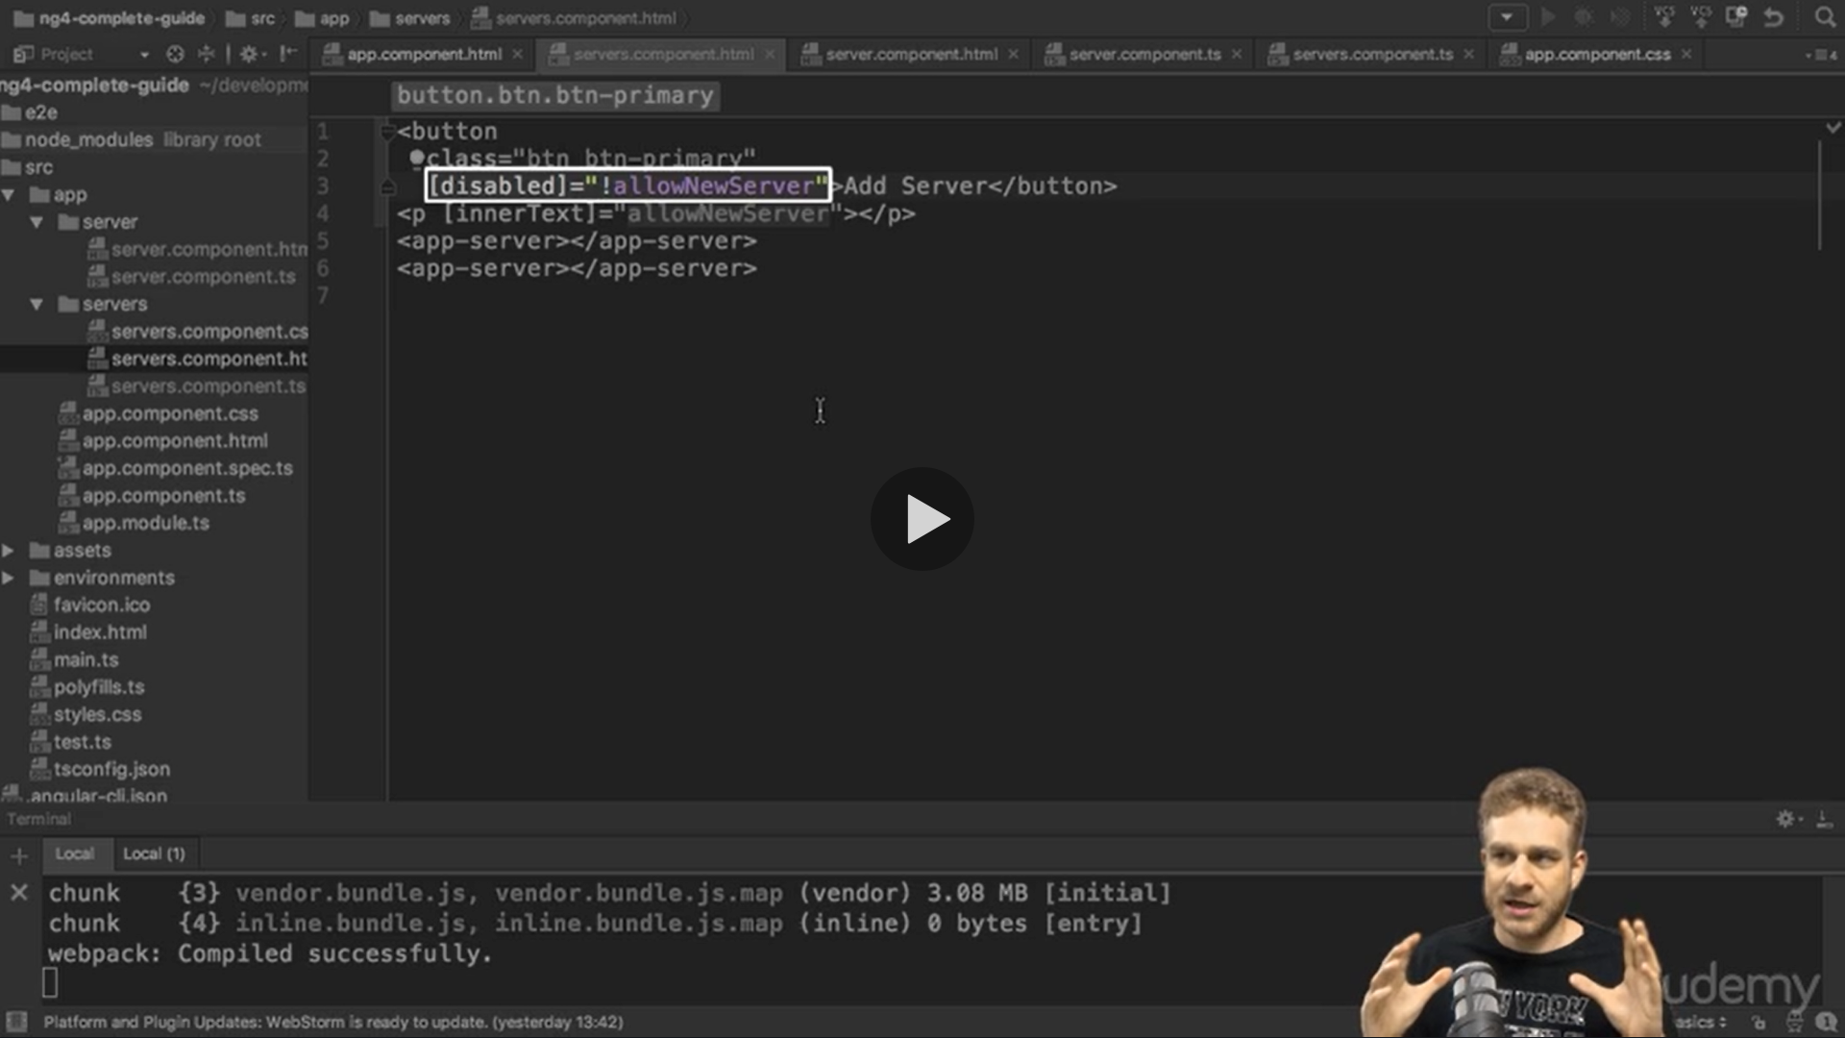

Event Binding

We added

serverCreationStatus="No server was created ";

and

onCreateServer(){

this.serverCreationStatus="Server was created ";

}

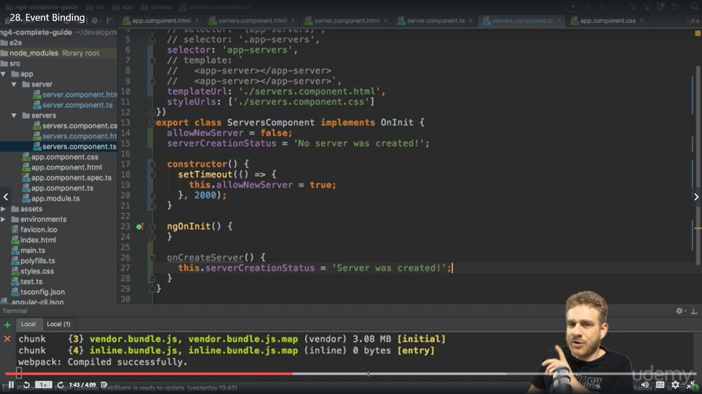

On HTML

<button

class="btn btn-success"

[disabled]="!allowNewServer"

(click)="onCreateServer()"

>Add Server</button>

<p>{{allowNewServer}}</p>

<P>{{serverCreationStatus}}</P>

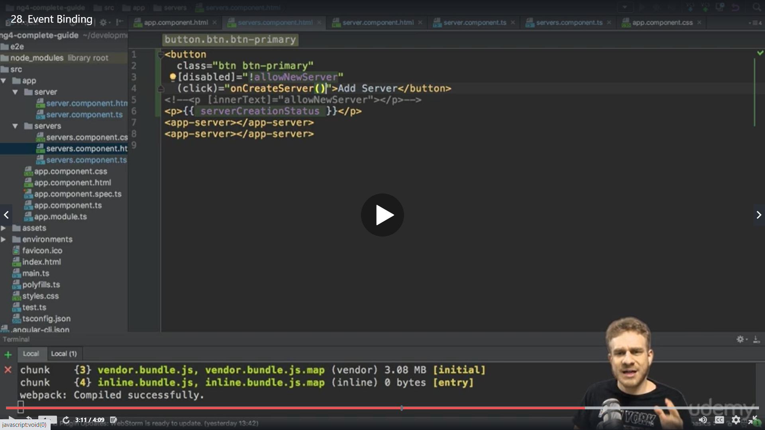

We can put the code as well which we want to execute in place of method

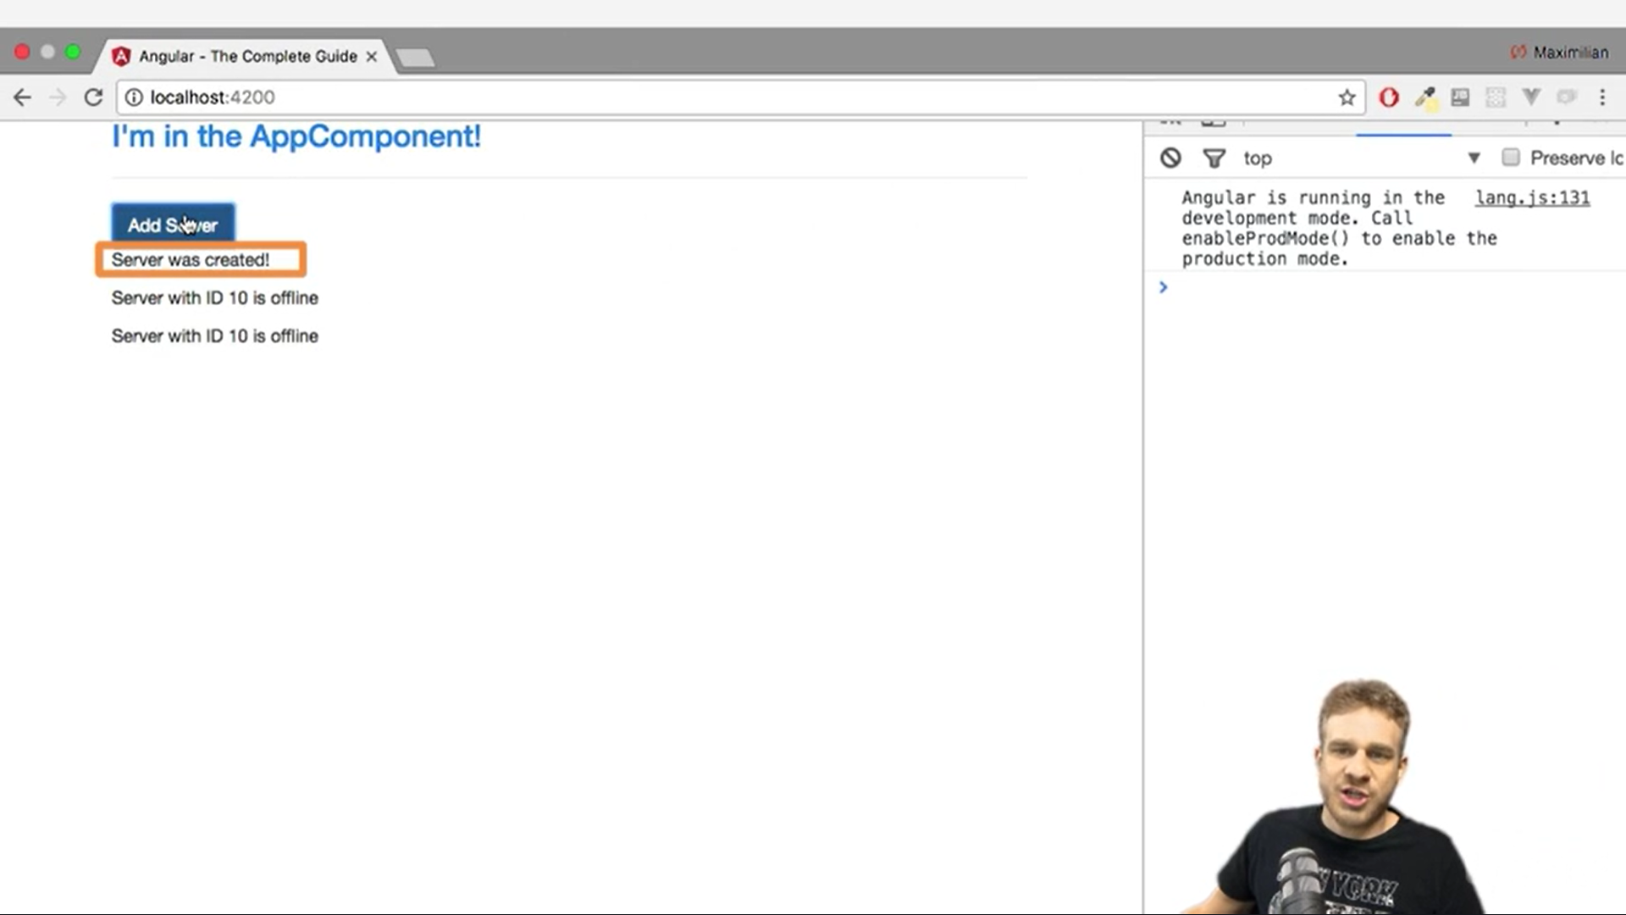

Bindable properties and event

How do you know to which Properties or Events of HTML Elements you may bind? You can basically bind to all Properties and Events - a good idea is to console.log()  the element you're interested in to see which properties and events it offers.

Important: For events, you don't bind to onclick but only to click (=> (click)).

The MDN (Mozilla Developer Network) offers nice lists of all properties and events of the element you're interested in. Googling for YOUR_ELEMENT properties  or YOUR_ELEMENT events  should yield nice results.

2 Way binding

We create an input event like click event here , input is one kind of an event

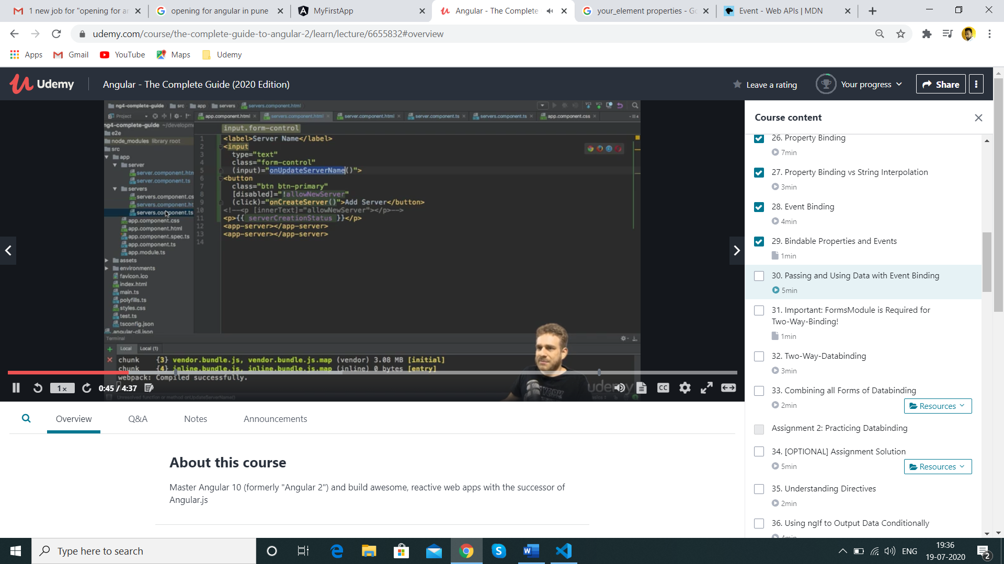

$event is a reserved variable name used in event when using event binding

Input & click are the events provided by DOM

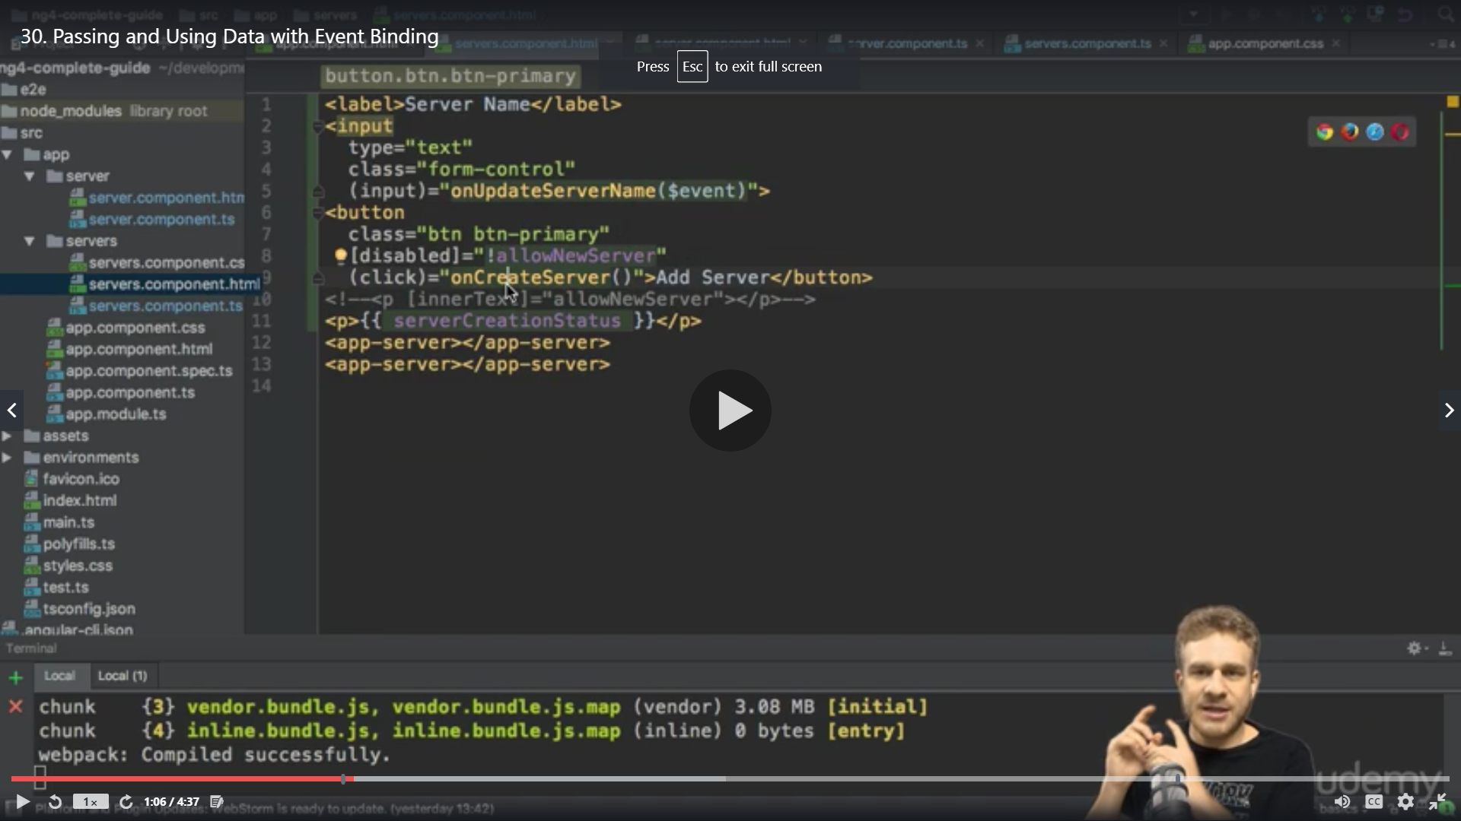

We create an instamce variable with name event and perform a console.log to see the event

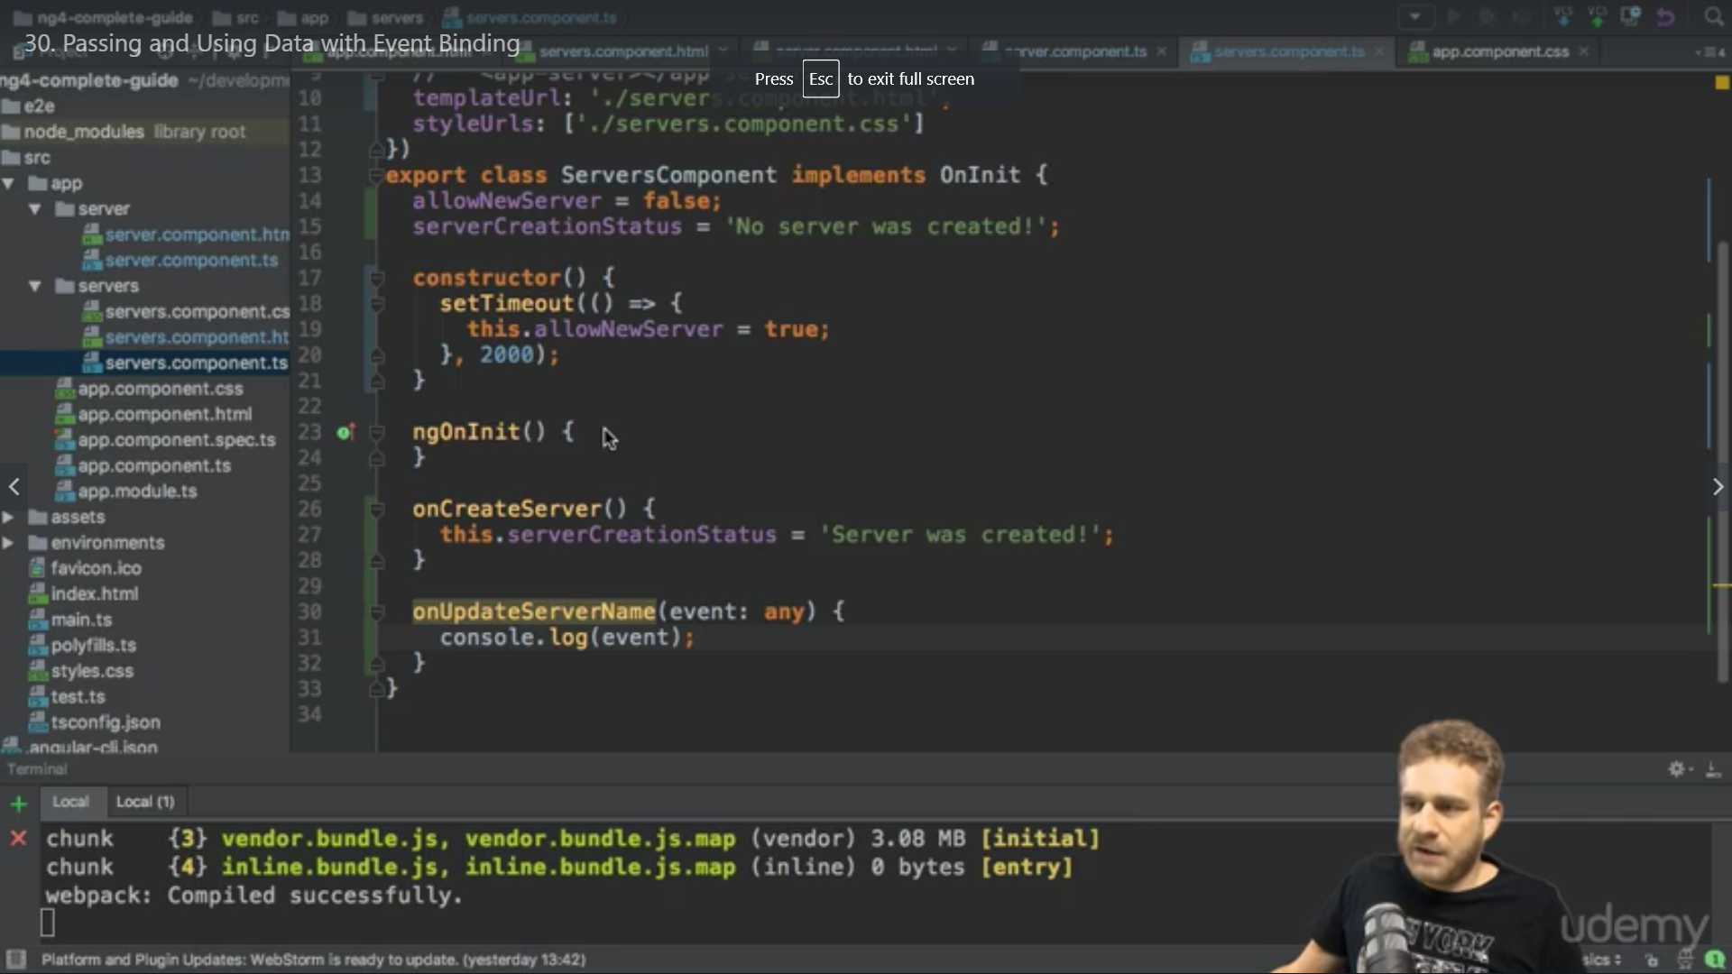

When we type anything in text box we get the event details

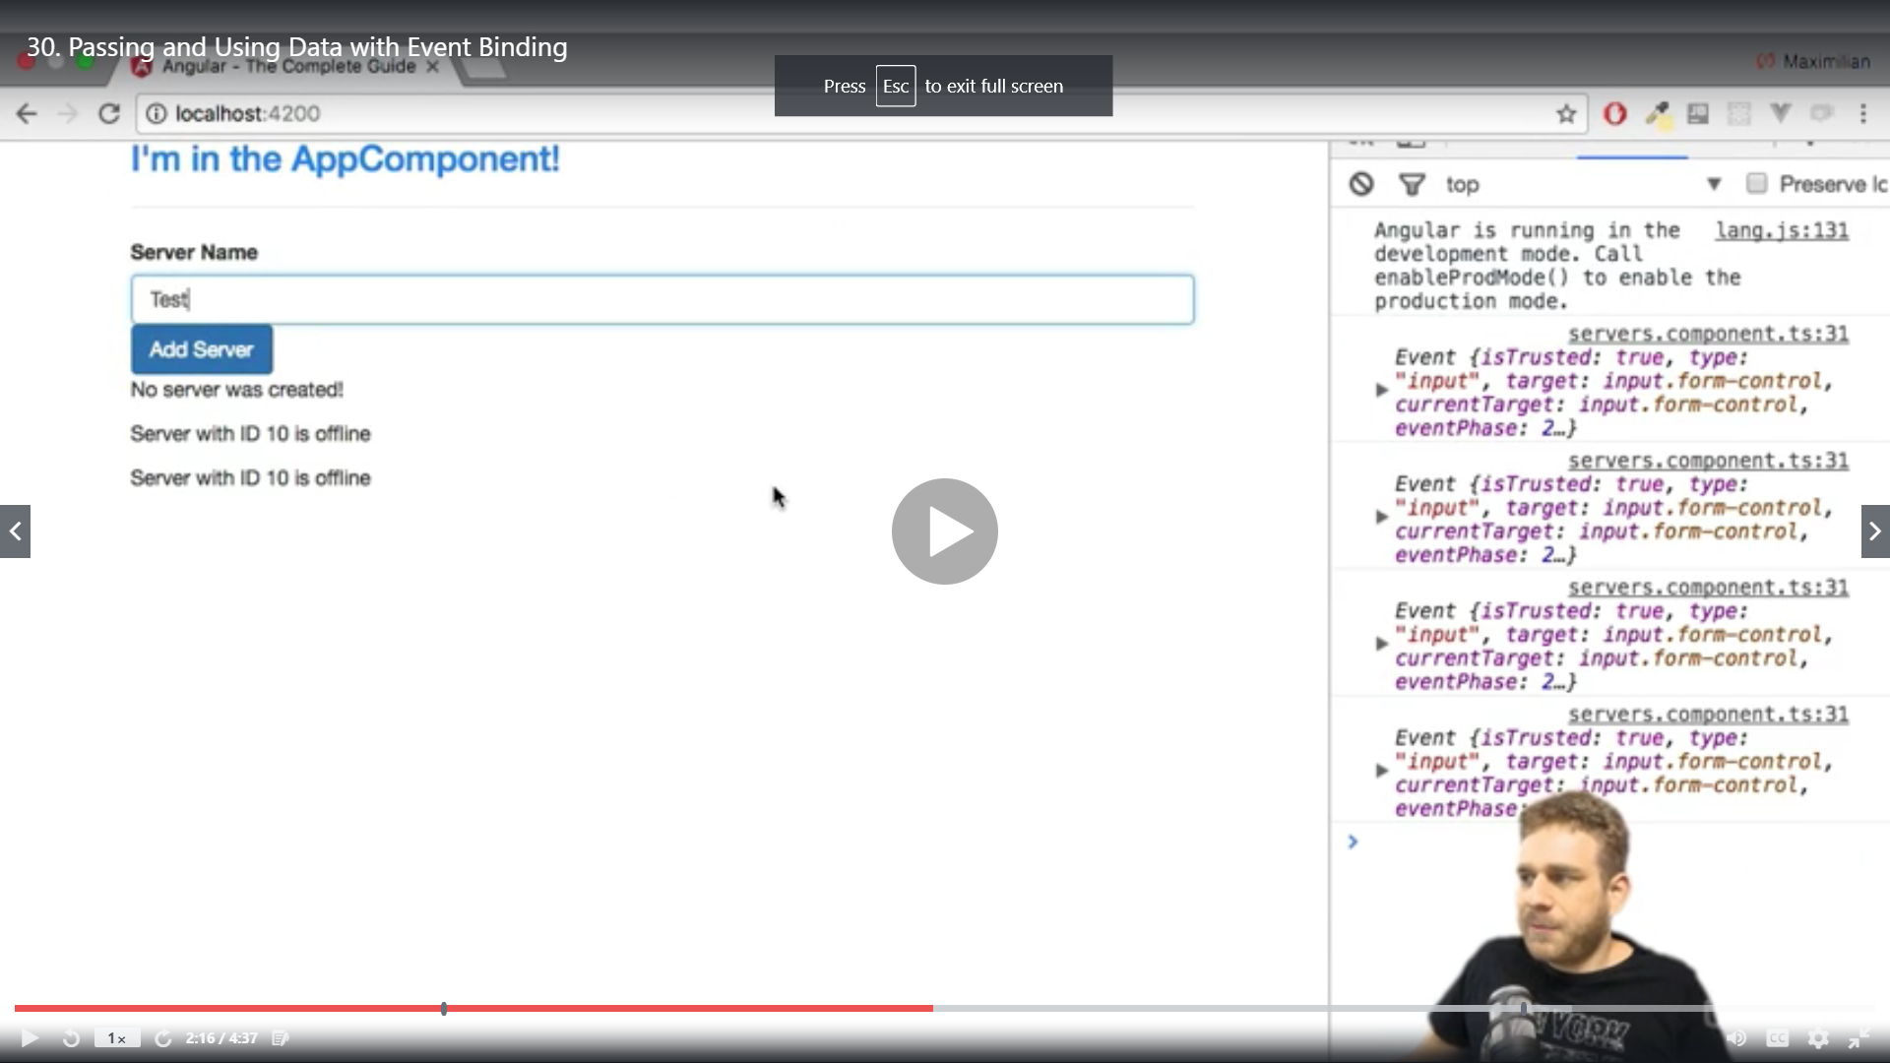

Two way Data binding

Important: For Two-Way-Binding (covered in the next lecture) to work, you need to enable the ngModel  directive. This is done by adding the FormsModule  to the imports[]  array in the AppModule.

You then also need to add the import from @angular/forms  in the app.module.ts file:

import { FormsModule } from '@angular/forms';

[(ngModel)]=”serverName” the ngModel will trigger the input event and setup the value of the serverName in our component

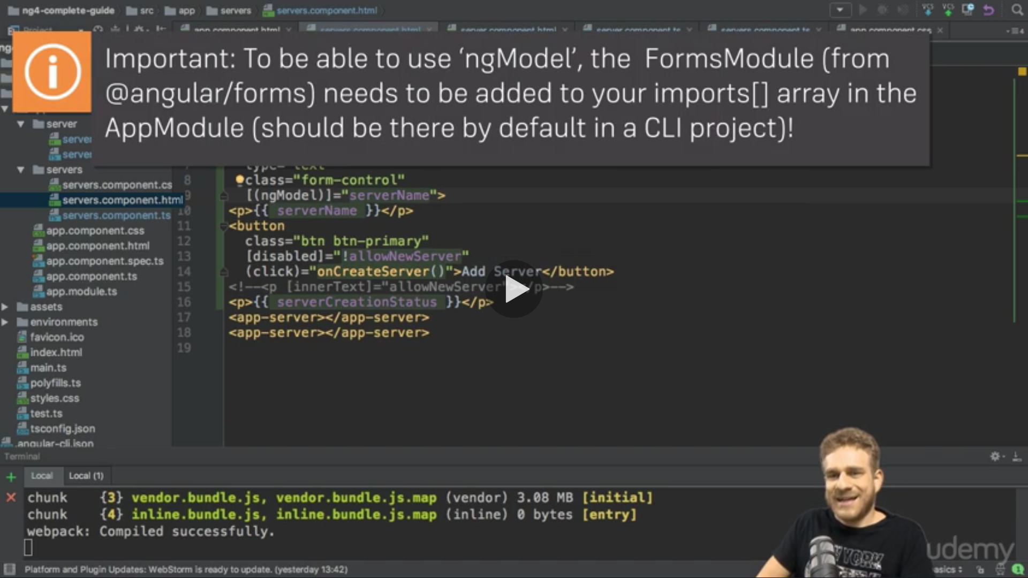

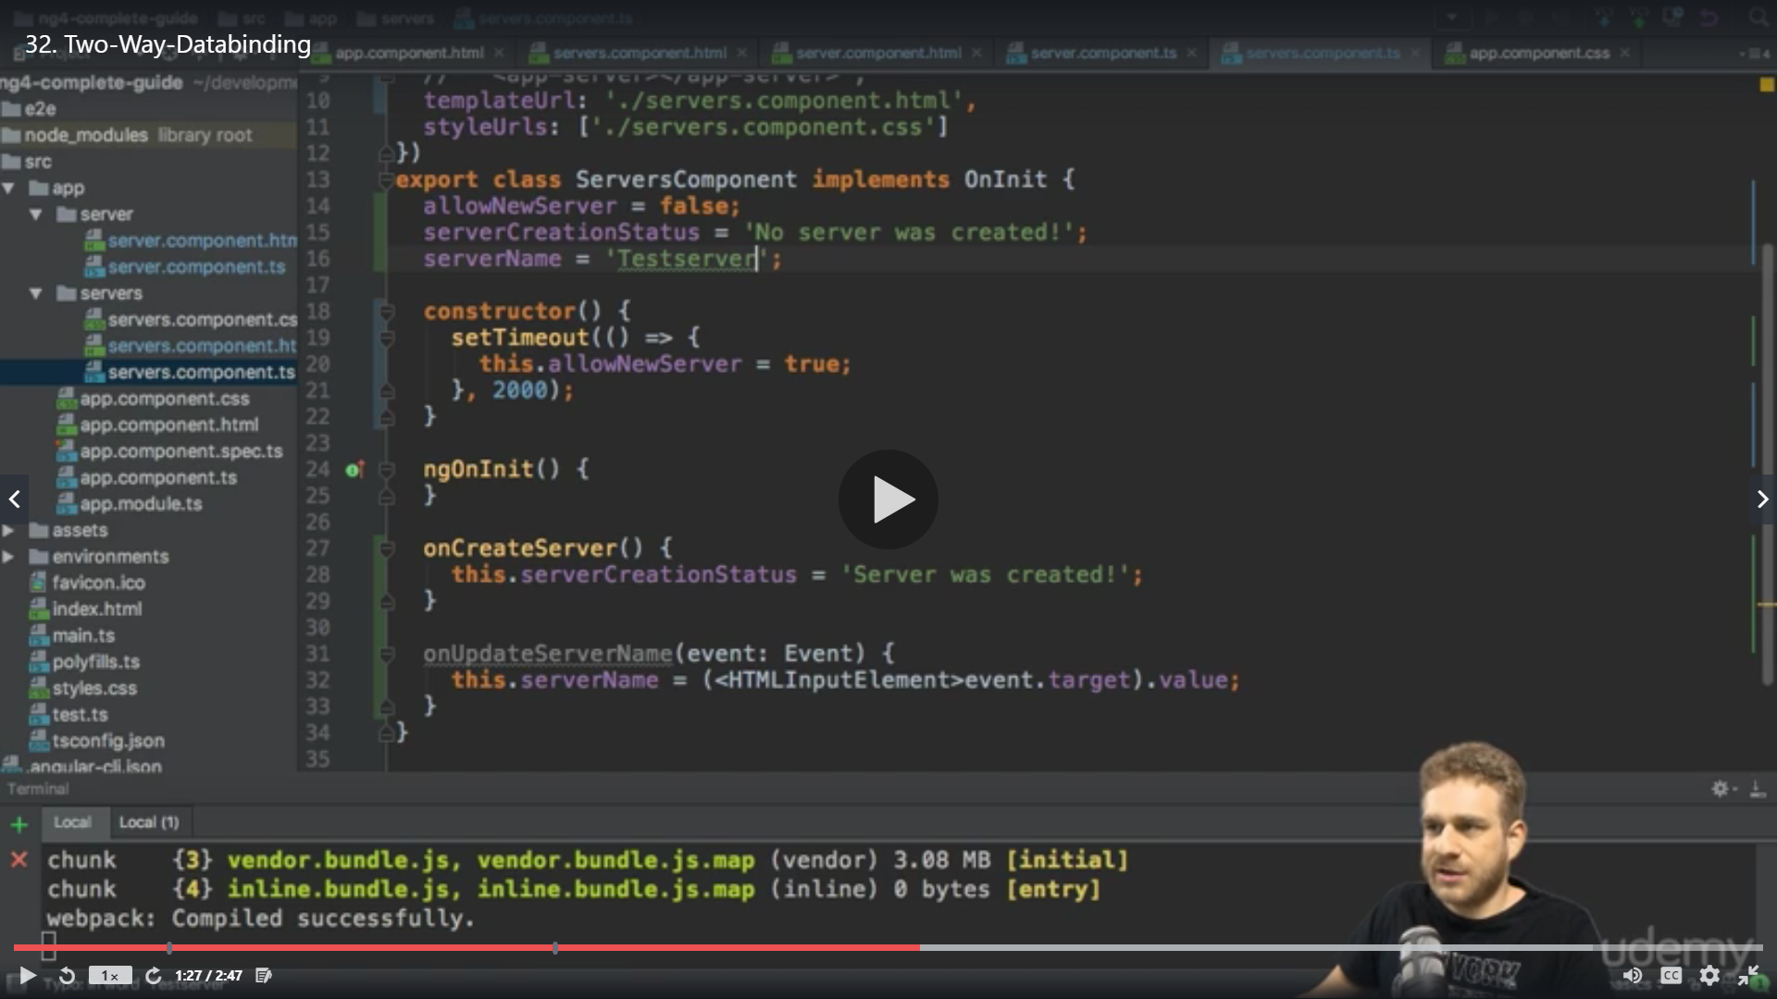

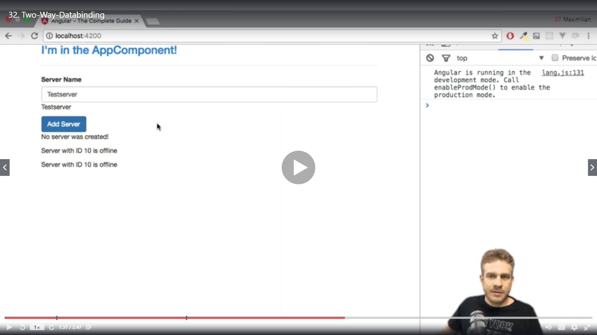

Add a text ,disable button if text is empty , reset to blank after click

<div class="container">

<div class="row" >

<label>Username</label>

<input type="text" class="form-control "[(ngModel)]="username">

</div>

<P>The username is ={{username}}</P>

<button class="btn btn-primary" [disabled]="username===''" (click)="username=''"> Reset</button>

</div>

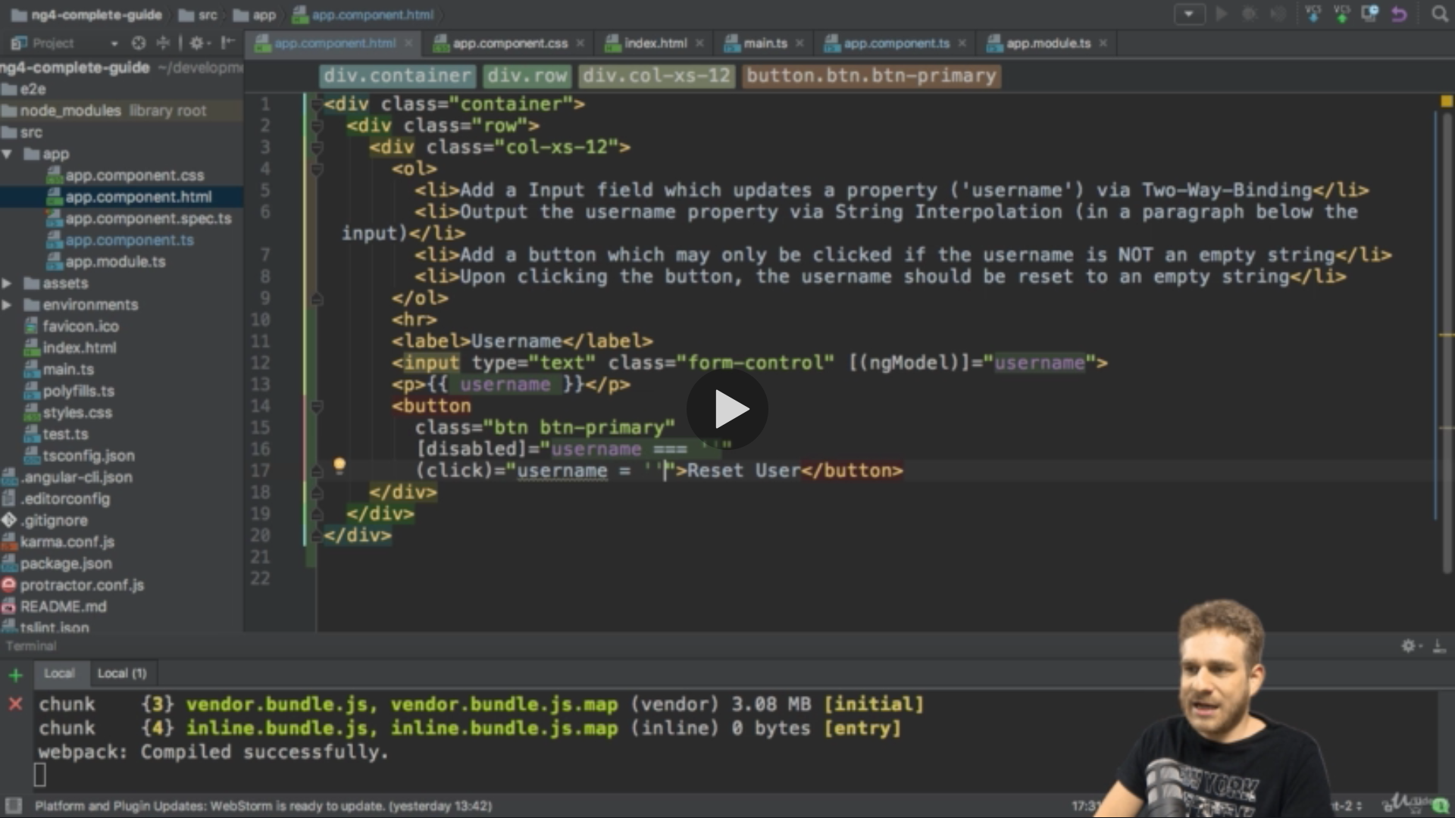

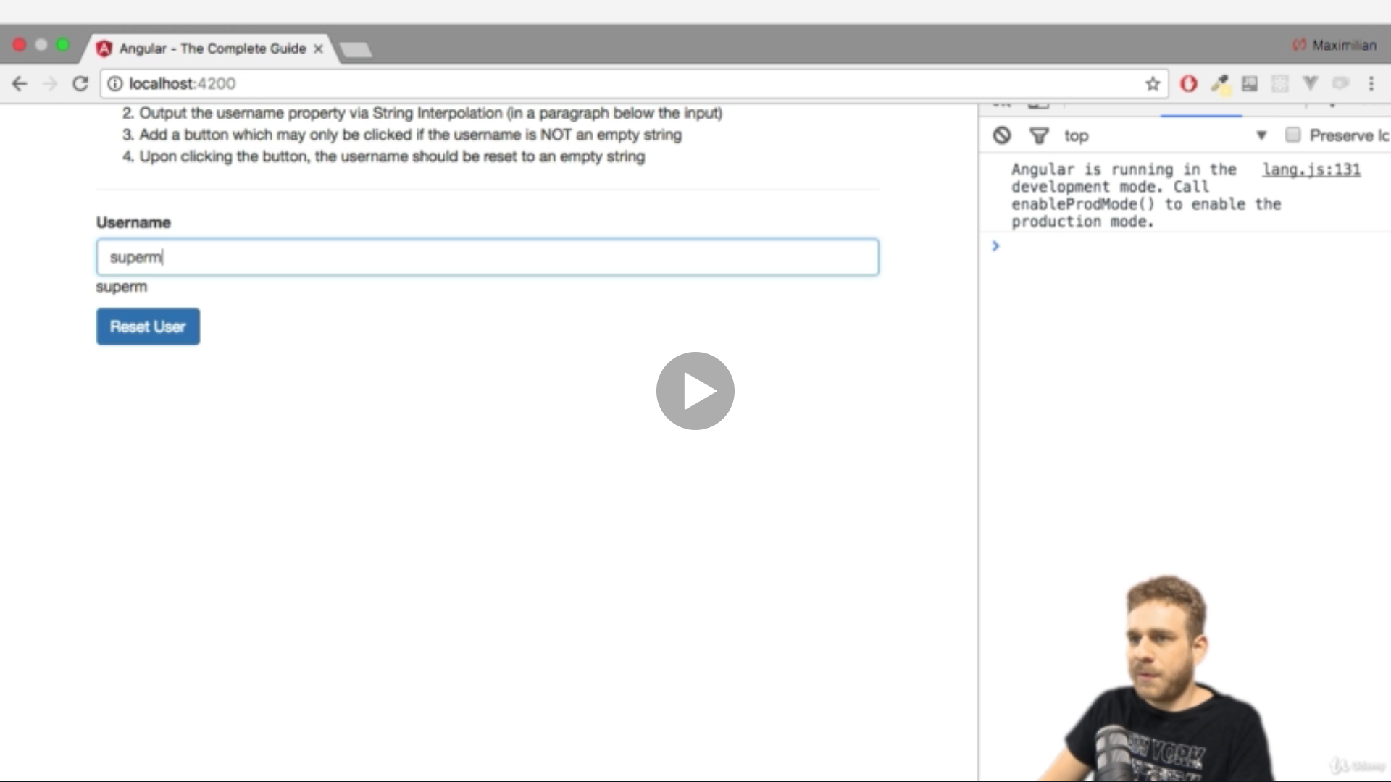

Reset

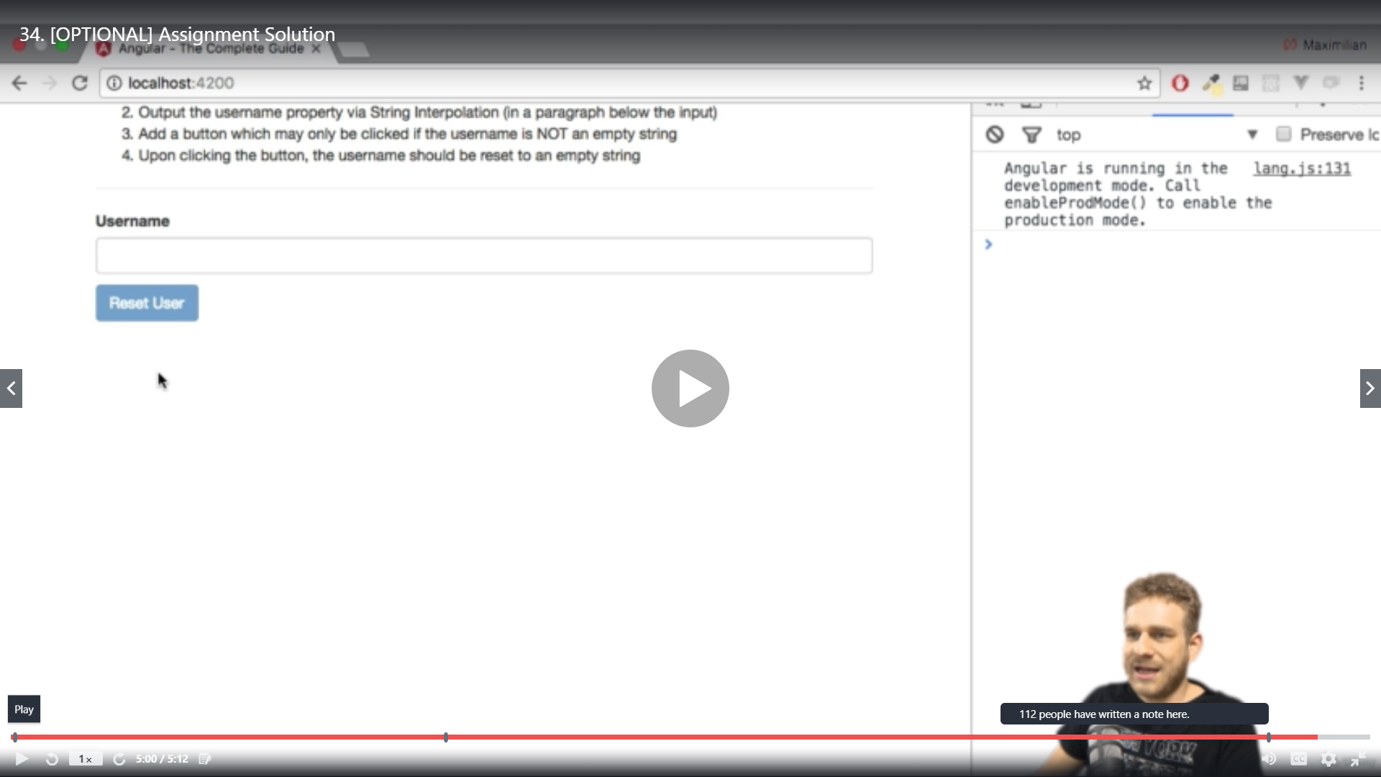

Directives

We can build our own directives

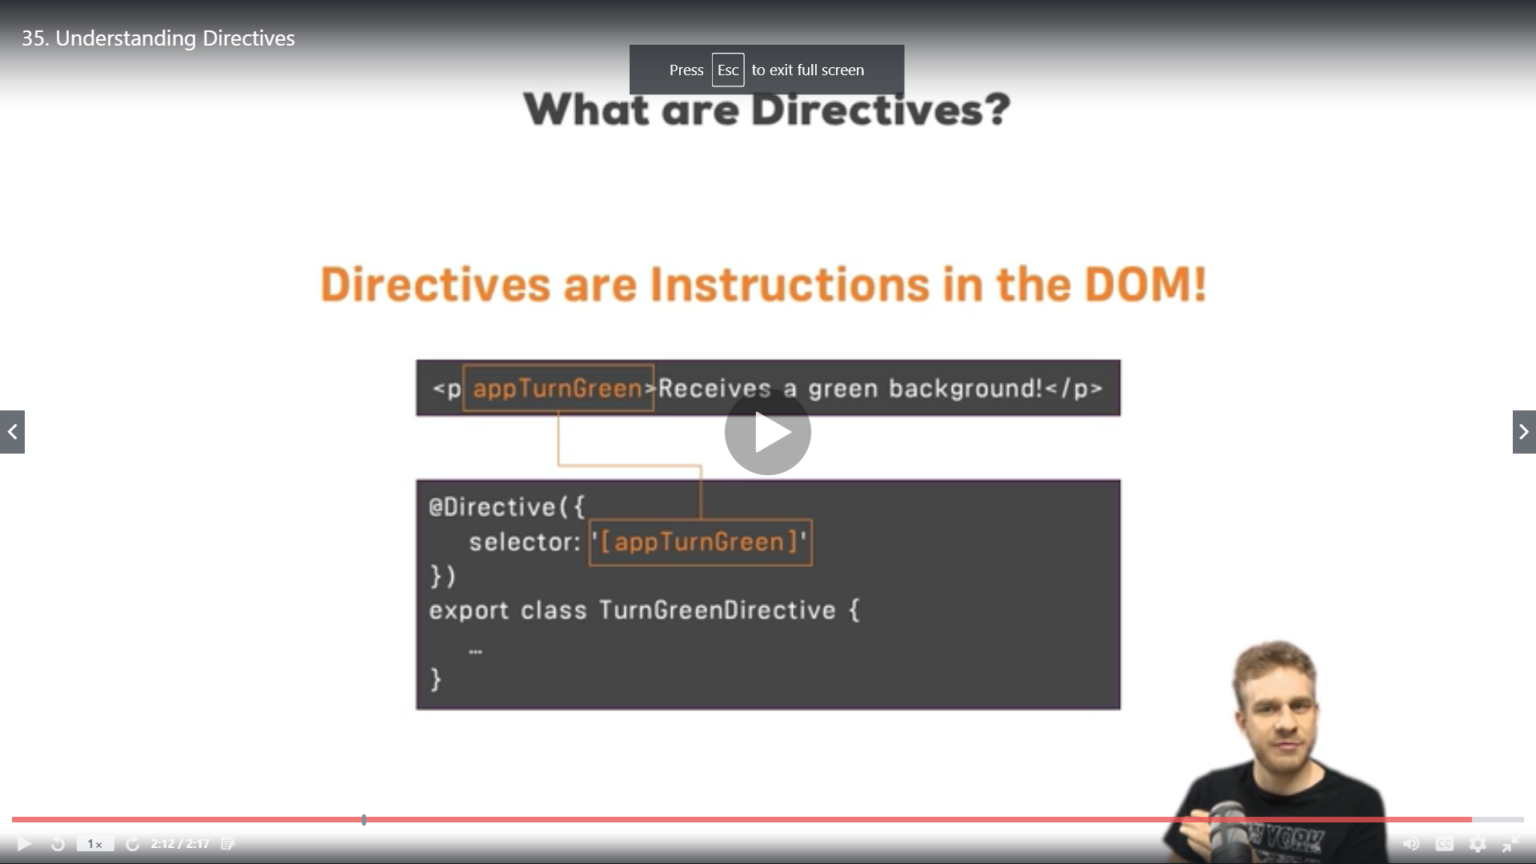

*ngIF

ngIf is a structural directive because it changes the structure of DOM ,without * it wont work correctly

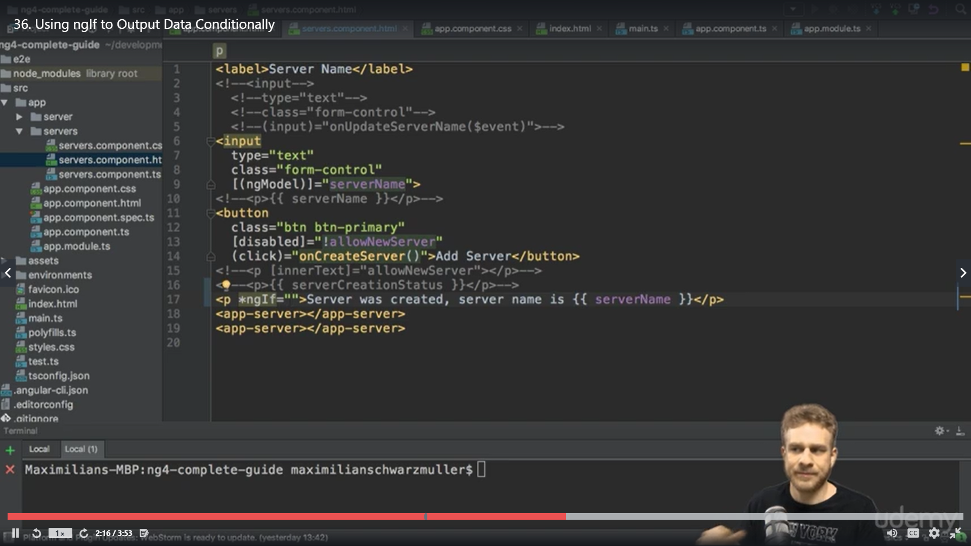

We added serverCreated =false and set it to true on createserver()

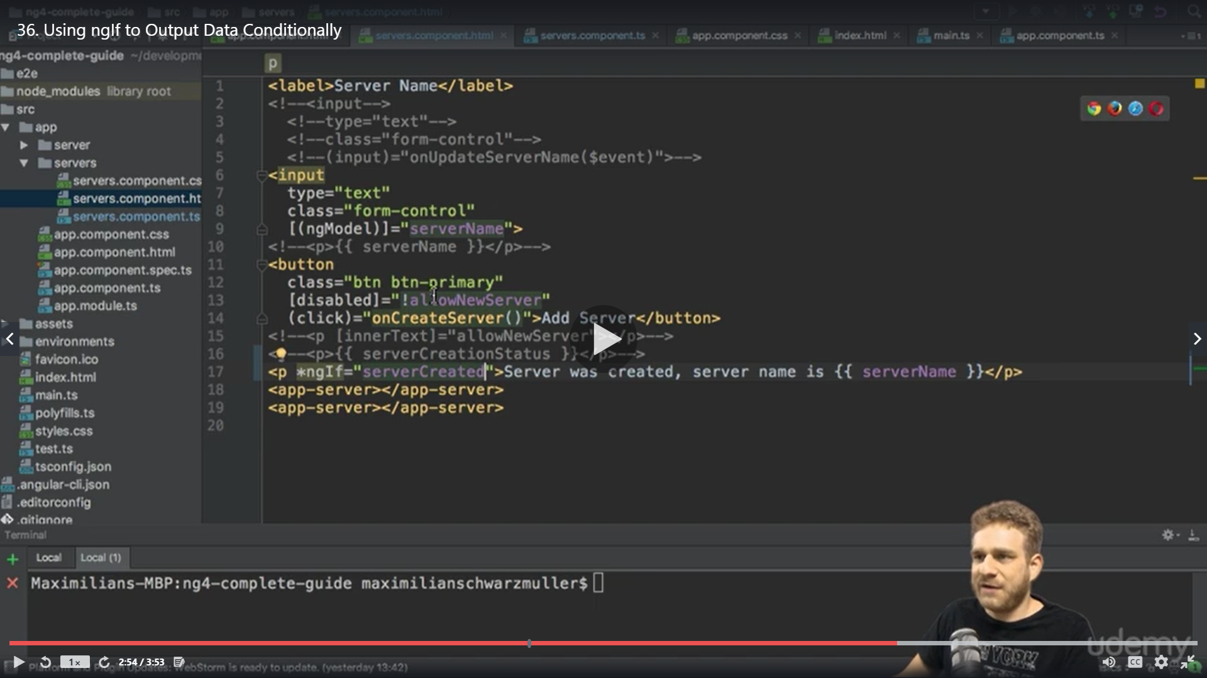

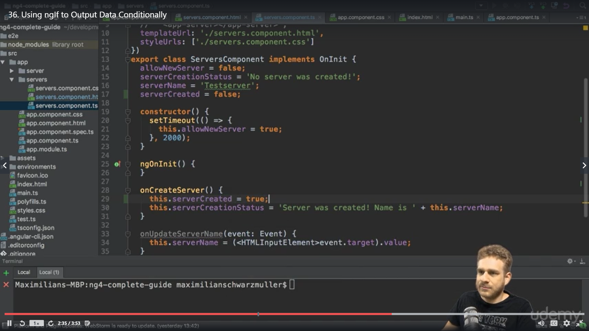

This directive is used to show result on basis of Boolean value ,this content is not hidden it is added or removed on the DOM ,when you inspect and run the app the element gets added

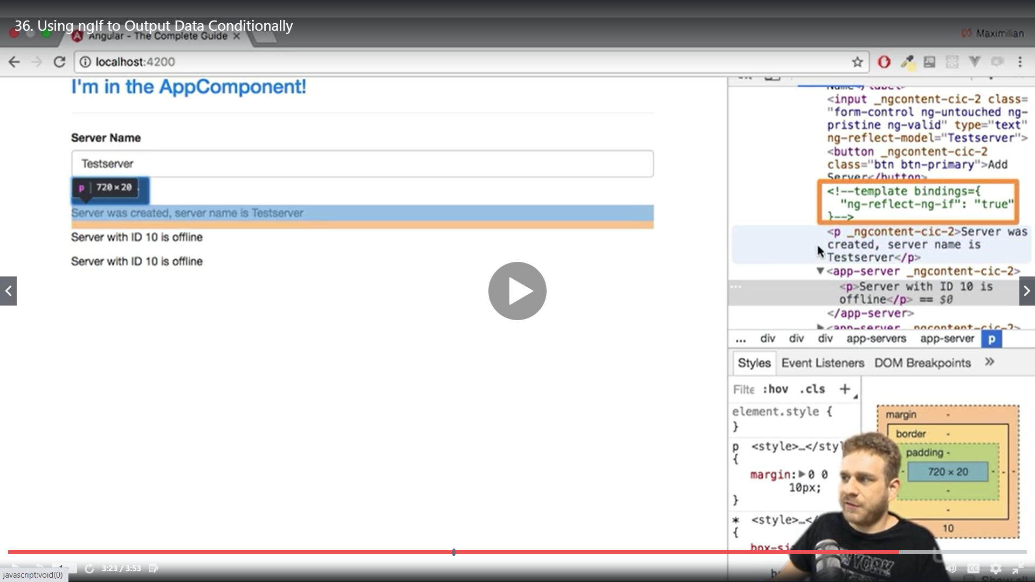

We can handle if else conditions by a local reference ie #

<ng-template > is used to mark places in the DOM

noServer is a random text and we need to modify the ngif as well

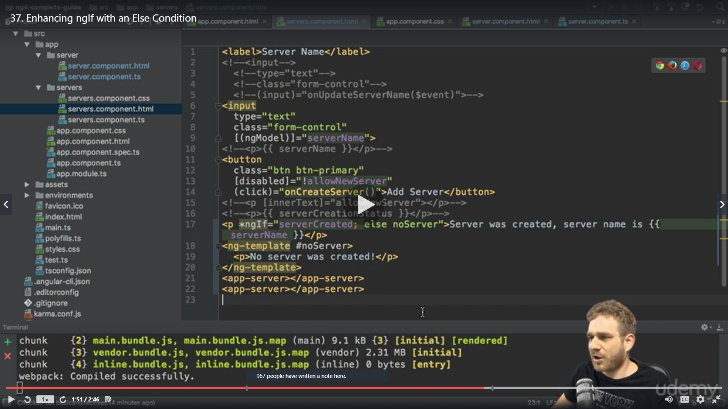

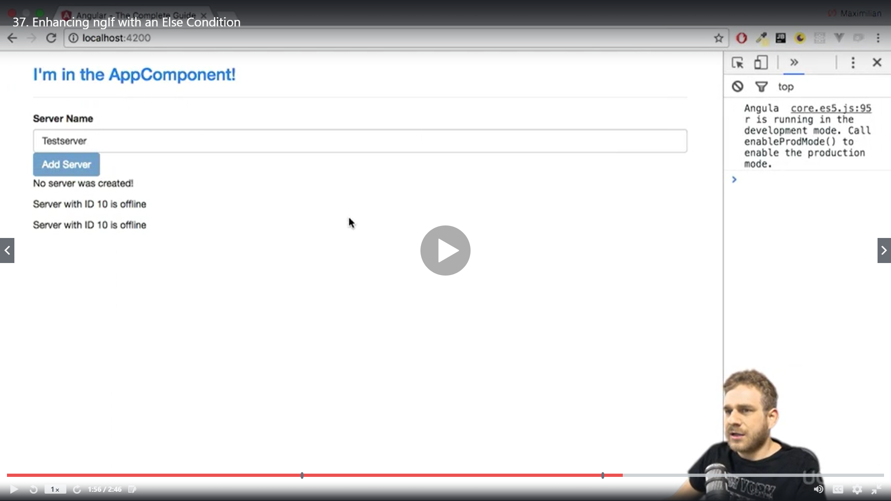

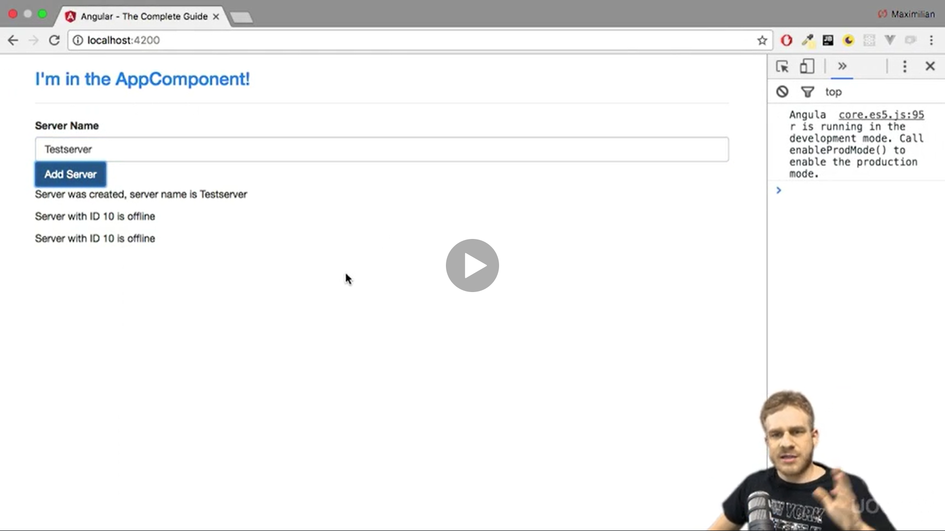

The alternative is to use ! for else case , the above was just a way

<p *ngIf="serverNgIf">My if block = {{serverCreationStatus}}</p>

<p *ngIf="!serverNgIf">My else is= {{serverCreationStatus}} </p>

ngStyle

ng style is an attribute directive they only change the element on which they are placed they do not change the structure

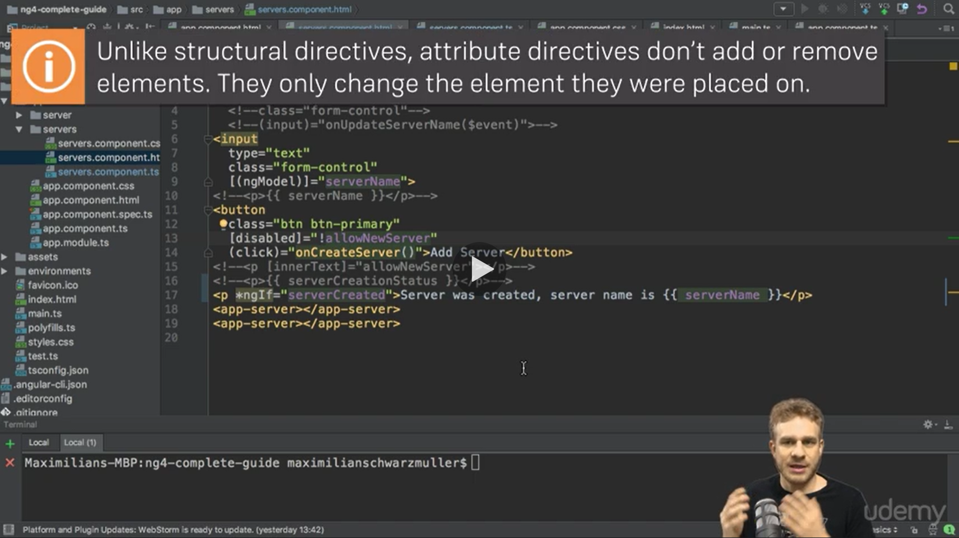

We perform an operation and assign value to serverstatus in constructor

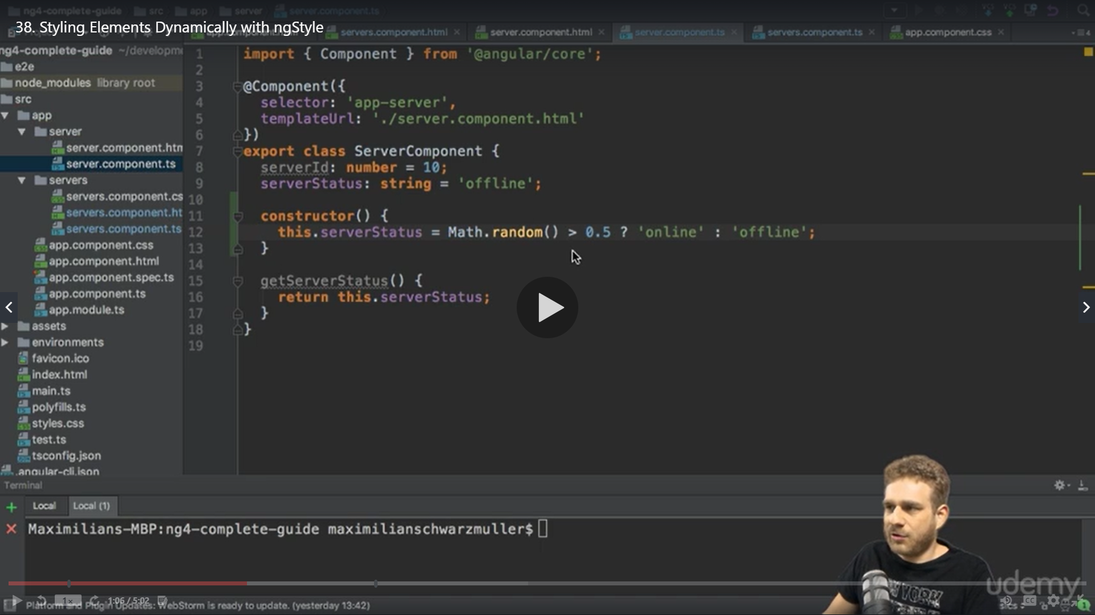

We have built in directive ngStyle to change the look dynamically we are using [] property binding and mentioning ngStyle as its value itself [ngStyle]

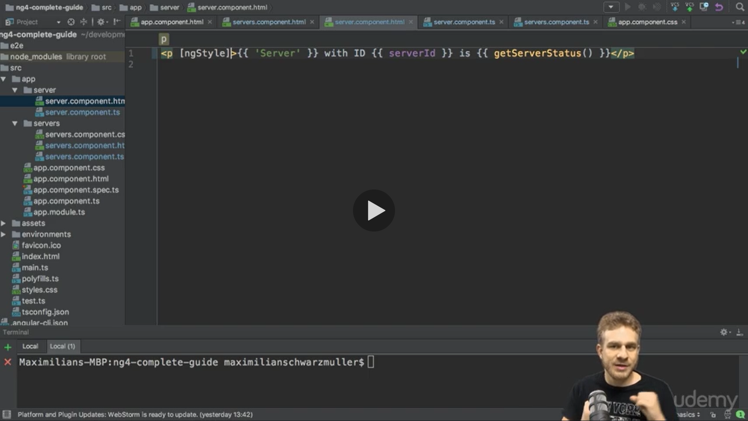

It holds the key value pair where background is the key and value is getColor()

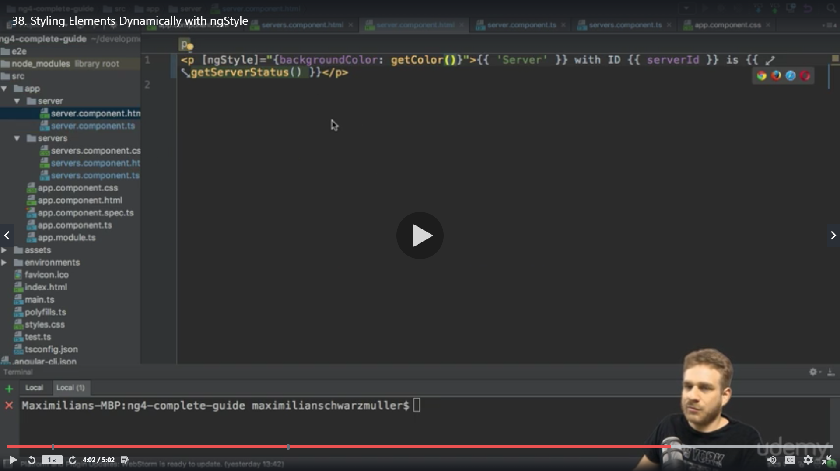

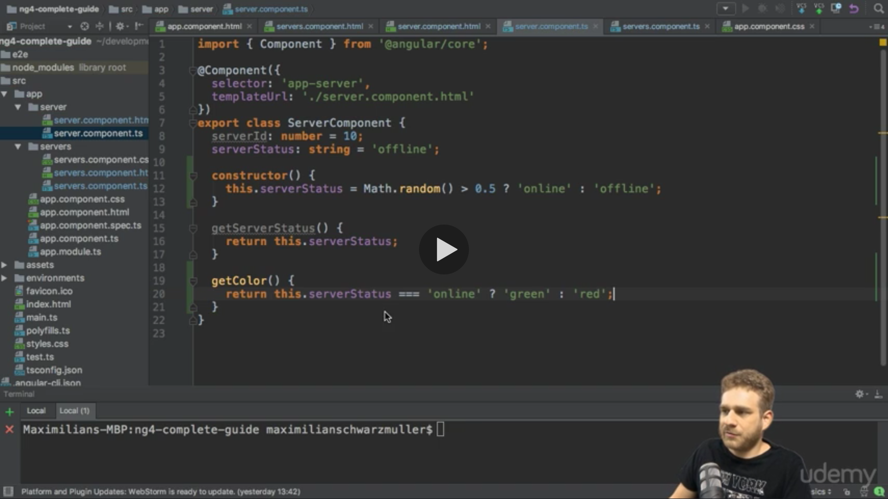

Here we want to return green if the server status is online else offline ? = then and : =else

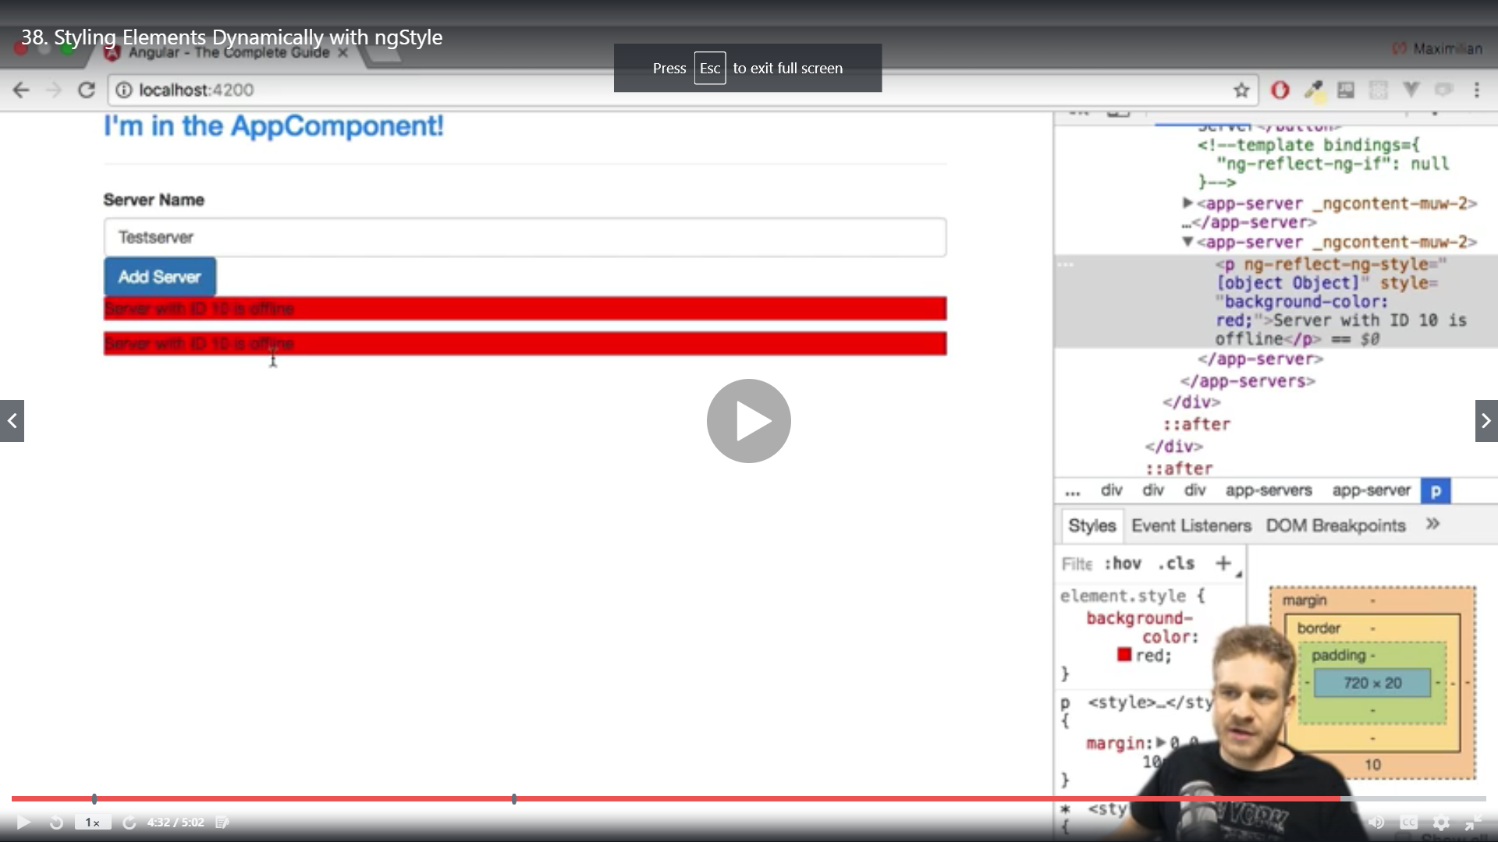

ngClass

ngClass allows us to dynamically add or remove classes , it only adds css class only if the condition is true

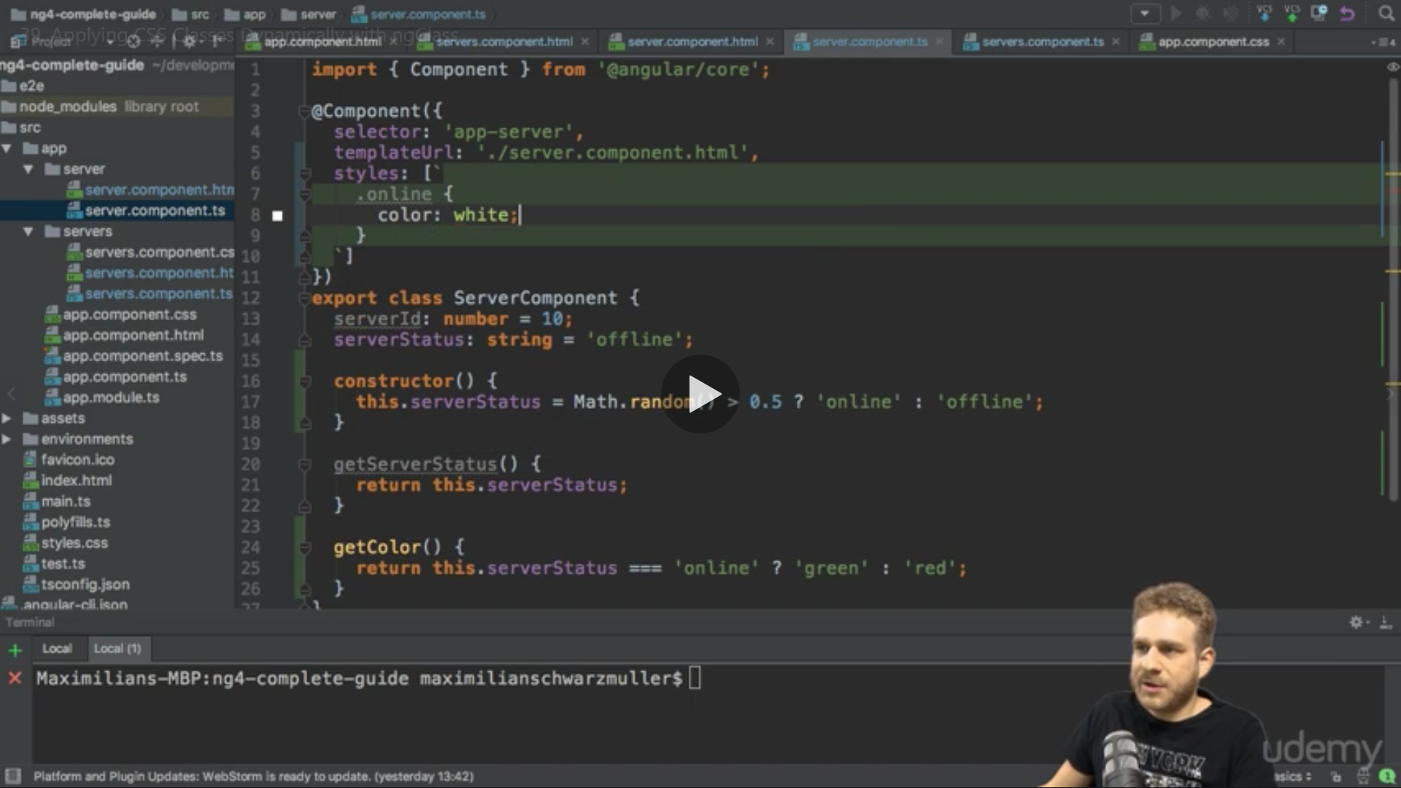

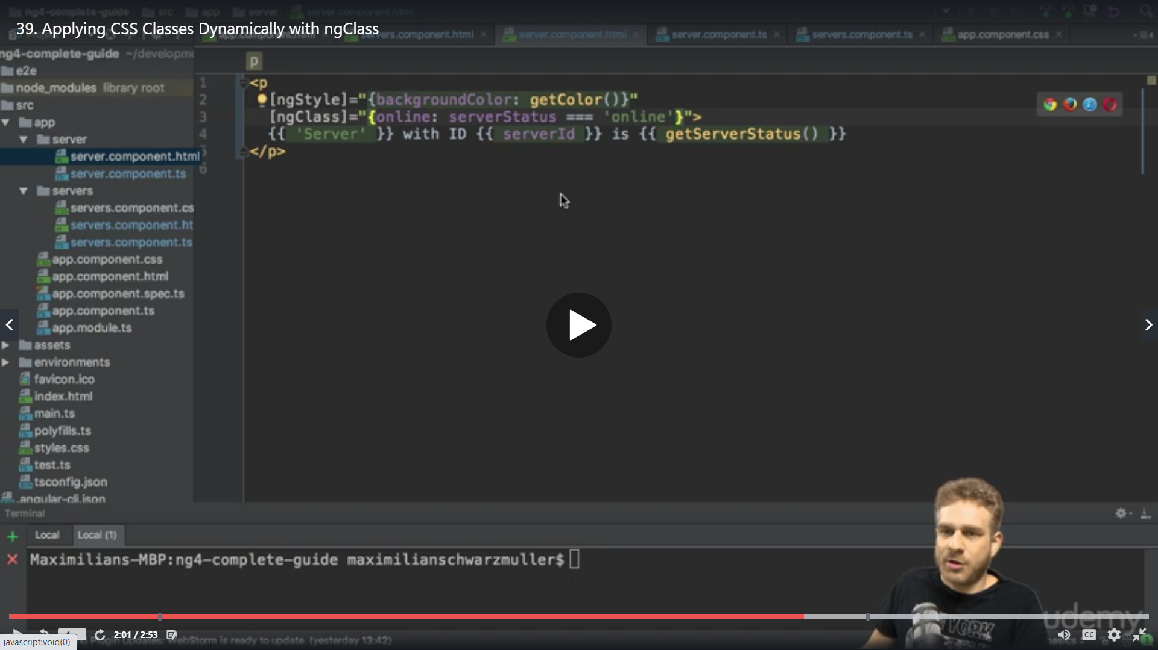

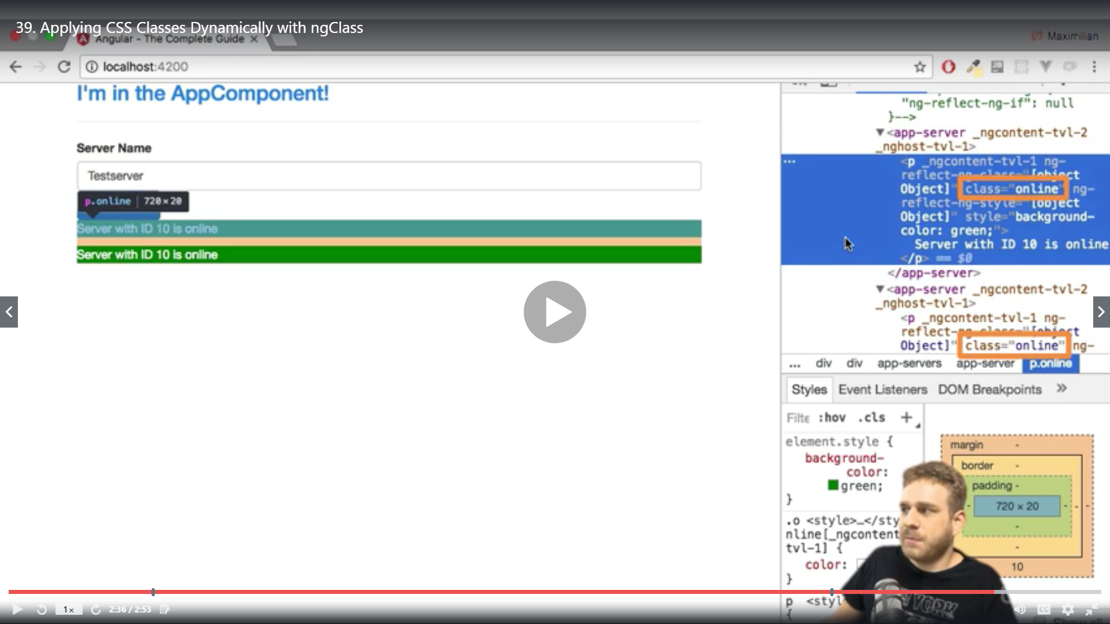

ngFor

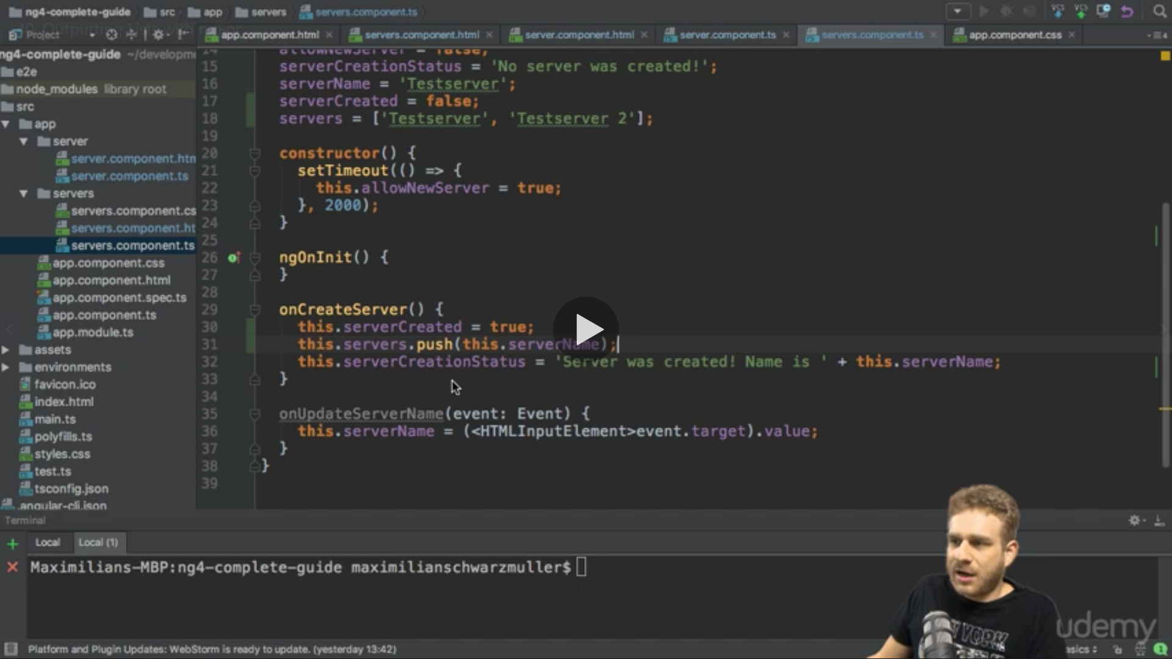

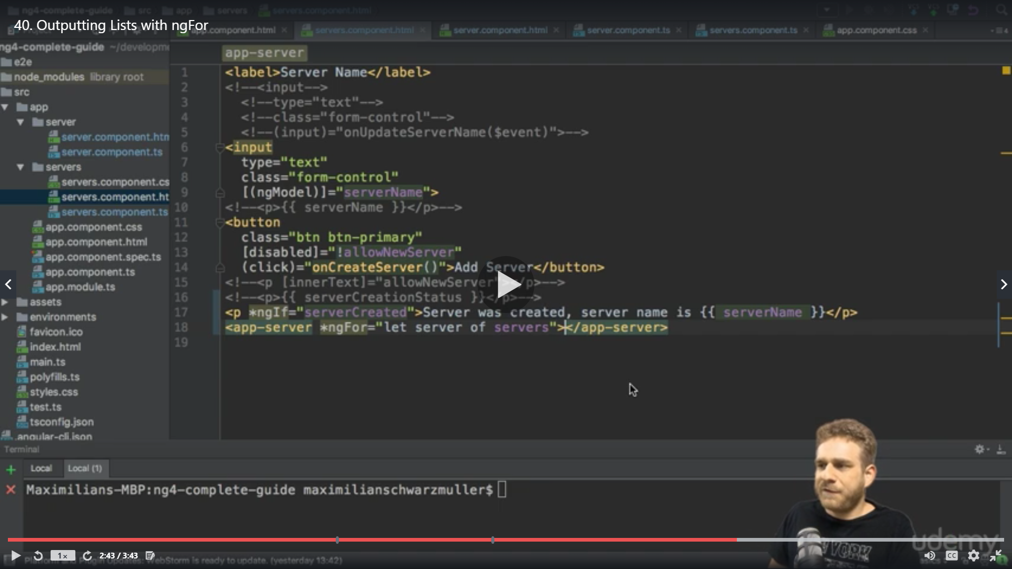

We can apply ngFor on selector tag as well , the result will be it will add the whole content again

<app-server *ngFor="let server of servers"></app-server>

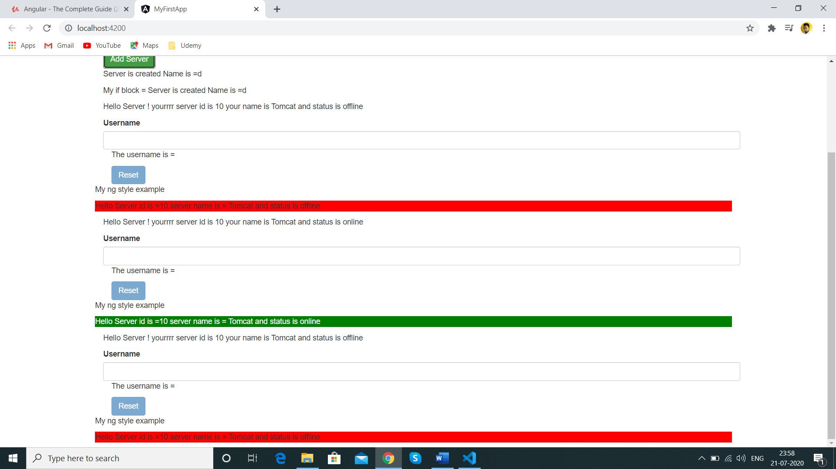

Assignment

 <div class="col-sm-6">

    <!-- <button class="btn btn-success" (click)="toogle=!toogle">Show</button> -->

    <button class="btn btn-success" (click)="showArray()">Show Items</button>

    <br>

    <div>

      <!-- <p *ngIf="toogle" >Name is ={{userName}}</p> -->

    </div>

    <div *ngFor="let items of itemss"  [ngStyle]="{backgroundColor: items >=4 ? 'green':'red'}" [ngClass]="{'arraytext':items>=4}"

      >{{items}}</div>

  </div>

 </div>

</div>

<!--

Alternate approch

<button class="btn" (click)="toggleParagraph()">Display Details</button>

<p *ngIf="paragraphVisible">Secret Password = tuna</p>

 <div>

  <div *ngFor="let item of log; index as i;" [ngStyle]="i > 3 && {'background': 'blue'}" [ngClass]="{'white-color': i > 3}">

   {‌{item}}

  </div>

</div> -->

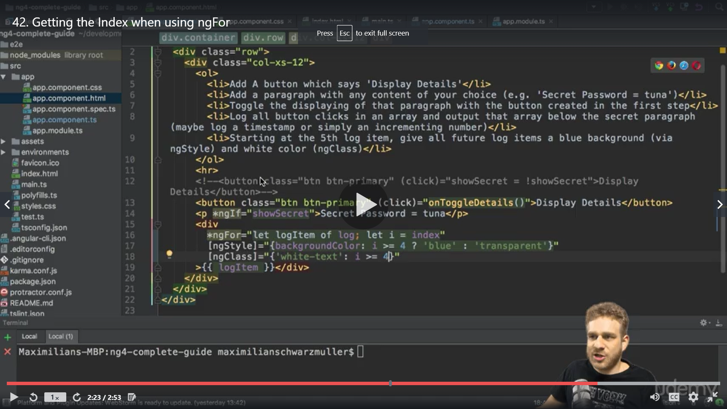

Trouble shoot link

<https://www.udemy.com/course/the-complete-guide-to-angular-2/learn/lecture/6655698#questions/8079942>

If you get an error message saying Job name "..getProjectMetadata" does not exist, please perform the following steps:

● Run npm i @angular-devkit/build-angular@0.803.25

● Restart ng s to serve the project on localhost:4200.

If you get an error message saying The Angular Compiler requires TypeScript >=3.4.0 and <3.5.0 but x.x.x was found instead, please perform the following steps:

● Run npm i --save-dev-exact typescript@3.4.5

● Restart ng s to serve the project on localhost:4200.

**Please note:**

**Unfortunately Udemy changed their link format in the meantime. If a link to a lecture doesn't work for you, please replace https://udemy.com/ by https://udemy.com/course/**

● **Latest zip without http** (prj-forms-final):

→ <https://www.udemy.com/the-complete-guide-to-angular-2/learn/lecture/6659492>

● **Latest zip before splitting up the app in multiple modules** (dyn-cmp-finished):

→ <https://www.udemy.com/the-complete-guide-to-angular-2/learn/lecture/14466480>

● **Latest zip without NgRX** (opt-mod-06-finished):

→ <https://www.udemy.com/the-complete-guide-to-angular-2/learn/lecture/14466522>

● **Latest zip with NgRX** (ngrx-12-finished):

→ <https://www.udemy.com/the-complete-guide-to-angular-2/learn/lecture/14466642>

● **Zip with server-side pre-rendering** (please note the different usage explained in that section!):

→ <https://www.udemy.com/the-complete-guide-to-angular-2/learn/lecture/15200414>